LAKIREDDY BALI REDDY COLLEGE OF ENGINEERING

(AUTONOMOUS)



**Department of Computer Science & Engineering**

|  |  |  |
| --- | --- | --- |
|  | **20CS60**  **COMPUTER NETWORKS LAB** |  |

Name of the Student:

Registered Number:

|  |  |
| --- | --- |
| **Branch & Section:**  Academic Year: 2021 2022 |  |

**LAKIREDDY BALI REDDY COLLEGE OF ENGINEERING**

**(AUTONOMOUS)**



**This is to certify that this is a bonafide record of the practical work done by**

**CERTIFICATE**

**Mr./Ms. ………………………………………………………., bearing Regd.Num.:20761A05…………..**

**Of B.tech…………Branch,……….Sectioninthe20CS60 - COMPUTER NETWORKS LAB**

**During the Academic Year:** 2021-2022.

**No. of Experiments/Modules held:10**

**No. Of Experiments Done:10**

** 2022 Signature of the Faculty**

**INTERNALEXAMINER EXTERNALEXAMINER**

**Index**

|  |  |  |  |
| --- | --- | --- | --- |
| **Name of the program** | **Page number** | **Date** | **Signature** |
| 1. To gain familiarity with the basic network commands & utilities available in the Linux OS. |  |  |  |
| 2. To learn about network layer tools and analyze captures for congestion. |  |  |  |
| 3. To learn about queue management techniques, and global routing in ns3. |  |  |  |
| 4. To learn about broadcasting, multicasting, and bridging in a Local Area Network using ns3. |  |  |  |
| 5. To learn about Wifi and Mobile Adhoc topologies with ns3. |  |  |  |
| 6. To introduce Socket Programming in TCP and UDP. |  |  |  |
| 7. Observations of Transmission Control Protocol (TCP) Connection states, Flags and Flow control. |  |  |  |
| 8. To learn Transmission Control Protocol (TCP) Flow Control, Error Control, and Congestion. |  |  |  |
| 9. To introduce Wireshark & tcpdump, and observation of packets in a LAN network. |  |  |  |
| 10. To analyze HTTP packets using Wireshark tool, and understand the records returned by a DNS server. |  |  |  |

Experiment-1

# Aim: To gain familiarity with the basic ‘networks’ commands & utilities available in the Linux OS.

Some general tips:

* If any command is not installed on your system, do **sudo apt-get update** on the Terminal followed by **sudo apt-get install <name>** to install it.
* To see more details about any command, type **man <name>** on the Terminal.
* Running **<name> -h** on your Terminal will display the help menu of that command.

# Procedure:

Run the following commands on your Terminal window.

1. Troubleshooting network hosts
   1. ping <address>

Short for **Packet InterNet Groper,** the ping command is used to test the ability of your computer to reach a specified destination computer. The ping command is usually used as a simple way to verify that a computer can communicate over the network with another computer or network device. The ping utility is commonly used to check for network errors, and works by sending **ICMP ECHO_REQUEST** to network hosts.

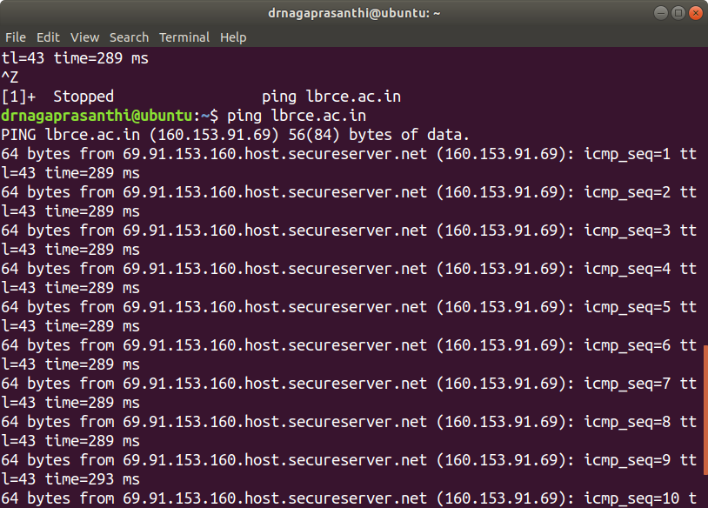

Figure.1. Output of ping command

Ping two different machines, one within India and the other one outside India, and observe the latency.

Understanding about network interfaces

* 1. ifconfig [options]

**ifconfig** is used to configure the network interfaces. It is used at boot time to set up interfaces as necessary. After that, it is usually only needed when debugging or when system tuning is needed.

If no arguments are given, **ifconfig** displays the status of the currently active interfaces.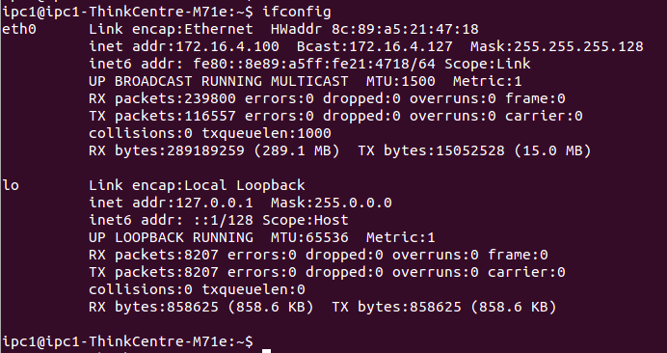

Figure.2. The output of “ifconfig” command

If a single interface argument is given, it displays the status of the given interface only;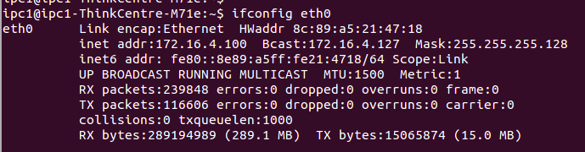

Figure.3. The output displayed on running “ifconfig eth0”

if a single **-a** argument is given, it displays the status of all interfaces, even those that are down.

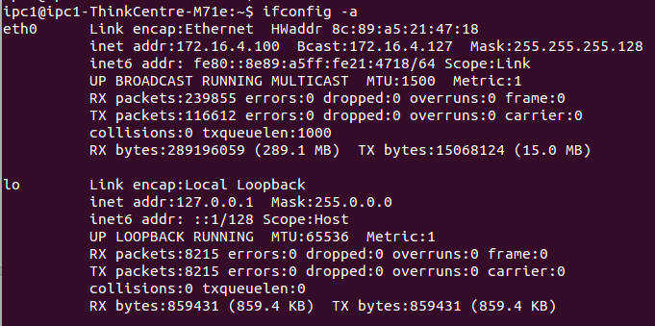

Figure.4. The output displayed on running “ifconfig -a” What is the IPv4 address of your computer?

What is the MAC address/HW address of your NIC card?

* 1. sudo ifconfig eth0 down

The above command will bring the ethernet interface down, meaning, the system would be disconnected from the network. Now, try to ping any network host. What is the observed output?

* 1. sudo ifconfig eth0 up

This command will call DHCP service which is involved in obtaining an IP address. Now, ping to any external system. What is the observed output?

* 1. ifplugstatus

The ifplugstatus command will tell you whether a cable is plugged into a network interface or not. It isn’t installed by default on Ubuntu. Use the following command to install it:

sudo apt-get install ifplugd

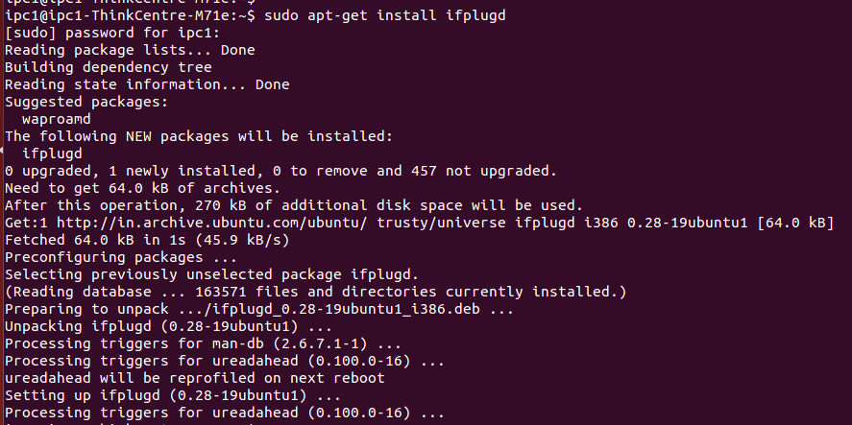

Figure.5. Installing “ifplugd” in Ubuntu system The output of ifplugstatus command when the cable is plugged.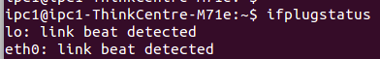

Figure.6. The output of “ifplugstatus” command

1. Finding all the intermediate network systems
   1. traceroute <address>

It isn’t installed by default on Ubuntu. Use the following command to install it: sudo apt-get install traceroute

traceroute is a command used to display the intermediate nodes through which a packet flows from a source location to a destination location. A program capable of doing the same in Microsoft Windows is **tracert**.

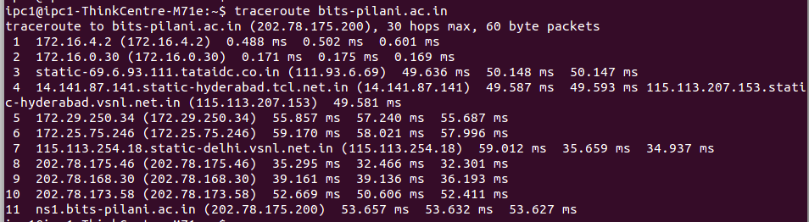

Figure.7. The output of “traceroute” command

Observe the latency for every hop, IP address of the First hop router, and First hop of your ISP, and Total number ISPs which your search explored.

1. DNS tools

Find the IP addresses of the following machines: bits-hyderabad.ac.in

swd.bits-hyderabad.ac.in sites.bits-hyderabad.ac.in

* 1. nslookup <address>

**nslookup** is a program to query Internet domain name servers. nslookup has two modes: interactive and noninteractive. Interactive mode allows the user to query name servers for information about various hosts and domains or to print a list of hosts in a domain. Non-interactive mode is used to print just the name and requested information for a host or domain.

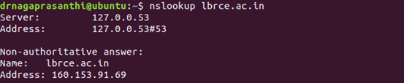

Figure.8. The output of “nslookup” command

* 1. host <address>

host is a simple utility for performing DNS lookups. It is normally used to convert names to IP addresses and vice versa. When no arguments or options are given, host prints a short summary of its command line arguments and options.

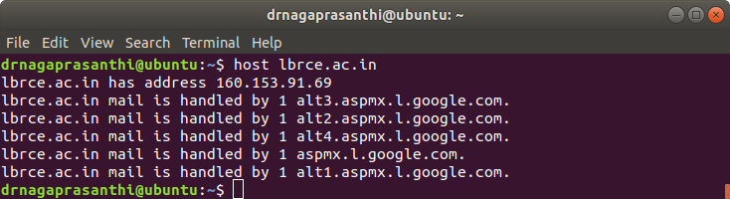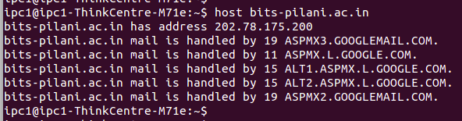

Figure.9. The output of “host” command

* 1. dig <address>

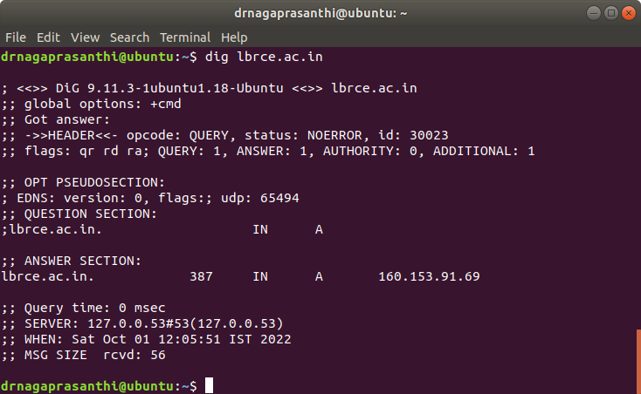**domain information groper** or **dig** is a flexible tool for interrogating DNS name servers. It performs DNS lookups and displays the answers that are returned from the name server(s) that were queried.

Figure.10. The output of “dig” command

* 1. DNS Configuration file

All DNS tools makes use of system DNS configuration file located at /etc directory (/etc/resolv.conf). The contents of the file should appear like the below screenshot.

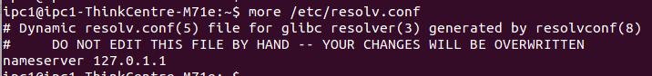

Figure.11. The configuration file “/etc/resolv.conf”

1. Copying files from/to a remote host
   1. scp

scp allows files to be copied to, from, or between different hosts. For example,

“scp remote_username@remote_host:/home/remote_username/file.txt /home/your_username” will copy the file “file.txt” (located at /home/remote_username) of the remote host

“remote_host” to your local directory (/home/your_username).

To download the tar file (CNLab1.tar) from host 172.16.4.100 to your system, the command is sudo scp ipc1@172.16.4.100:/home/ipc1/CNLab1.tar /home/ipc1

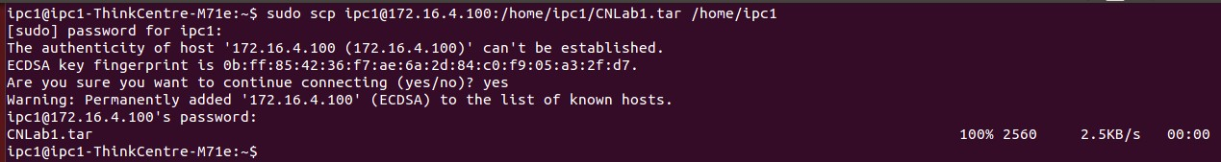

Figure.12. Ubuntu Terminal Output

To upload a tar file (2011A7PS111H.tar) from your local directory to a remote directory, the command is

sudo scp /home/ipc1/2011A7PS111H.tar ipc1@172.16.4.100:/home/ipc1



Figure.13. Ubuntu Terminal Output

Now, try to download the folder (/home/ipc1/Lab1) from host 172.16.4.100 to your local PC. Also, try to upload your own folder to a remote host. (The folder and all its contents including sub-folders should be copied).

1. To test the speed of internet connection

Run the following commands for installing speedtest-cli package.

sudo apt-get install python-pip sudo pip install speedtest-cli

After installation, type “speedtest” in the Terminal and press enter. The output should be similar to the figure below.

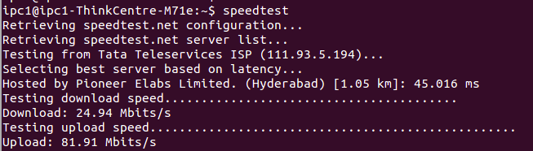

Figure.14. Ubuntu Terminal Output

References:

1. Linux ‘man pages’ available at [http://linux.die.net/man/](http://www.google.com/url?q=http%3A%2F%2Flinux.die.net%2Fman%2F&sa=D&sntz=1&usg=AFQjCNFGMIza-8K_aJ4xqzNICsJjvXMyHg)
2. [http://www.computerhope.com/](http://www.google.com/url?q=http%3A%2F%2Fwww.computerhope.com%2F&sa=D&sntz=1&usg=AFQjCNF36_1kuvJiFxBlKXrxZXIhdqfDbQ)

<http://www.webupd8.org/2014/02/how-to-test-internet-speed-via-command.html>

**Experiment-2**

**AIM:- To learn about network layer tools and analyze captures for congestion.**

**To view routing table entries:**

A routing table, or routing information base (RIB), is a data table stored in a router or a networked computer that lists the routes to particular network destinations, and in some cases, metrics (distances) associated with those routes. The routing table contains information about the topology of the network immediately around it. The construction of routing tables is the primary goal of routing protocols.​ Static routes are entries made in a

routing table by non­automatic means, which are fixed rather than being the result of some network topology "discovery" procedure.

“route” command is used to print, add, delete, edit routes in kernel’s IP routing table. Its primary use is to set up static routes to specific hosts or networks via an interface after it has been configured with the ​ifconfig program. When the **add**​ or **del**​ options are used, **route** modifies the routing tables. Without these options, **route**​ displays the current contents of the routing tables.

Tools used: **route**​ ​**, ip route**

Experiment 1:

1. Print routing table of your system. Use manual pages to capture observations that follow.

a. The command is “route”. Type “route” in Ubuntu terminal.

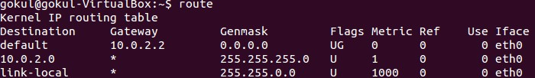

# Figure.1.1 “route” output

1. What is the IP address of the default gateway (in your IPC system)?
2. What does the flags ‘U’ and ‘G’ represent?
3. What is the metric value for default gateway?

b. Option “­n” displays all symbolic references in numeric values.

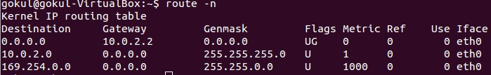

# Figure.1.2 “route” numeric output

a) Which route will be taken by a packet with destination address as 172.16.5.128?

c. For faster processing, the routing table is stored in kernel cache. To retrieve table from cache, use option “​­C”. By default, “route” command shows the table​ stored in FIB.



Figure.1.3 “route” output from kernel cache

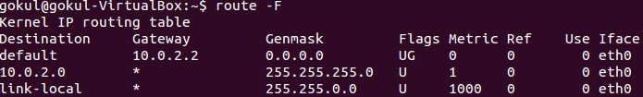

# Figure.1.4 “route” output from FIB

d. To display all the information in the routing table, use option “ee”.

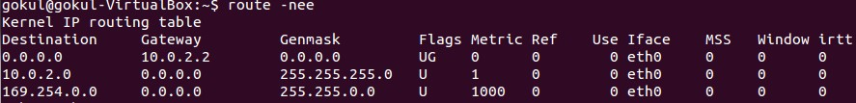

# Figure.1.5 “route” long listing

a) What are MSS and Window?

e. “netstat” command can also be used to display routing table.

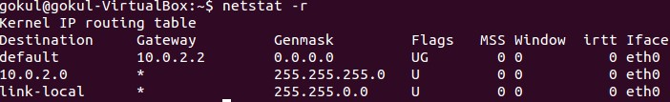

# Figure.1.6 “netstat” for displaying routing table

2. Add a route to the kernel route table

a. In order to add/delete routes, you should have root privileges. In the below figure, a loopback address is added to the route.

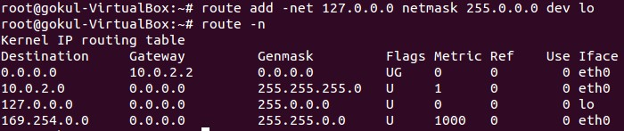

# Figure.1.7 Adding a loopback address

a) what happens when you add options of “​window 6000 mss 1440 irtt 300” to the route command in the above figure (note: to ‘add’ the route again,​ you must ‘delete’ it first as explained in step 3)

b. In the below figure, a route to IP address “192.56.76.0” is added. The next hop is interface eth0.

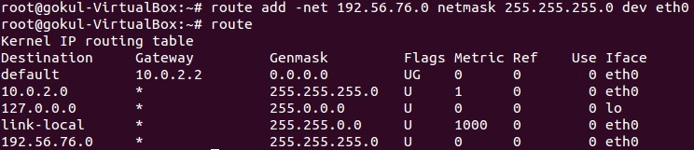

Figure.1.8 Adding “192.56.76.0” as IP address

3. Delete a route in the kernel route table

1. Delete route for IP address “192.56.76.0” created in step 2b.

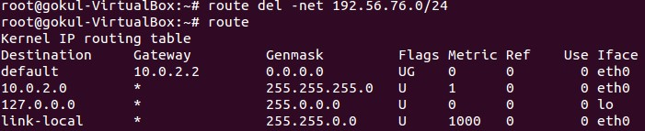

Figure.1.9 Delete “192.56.76.0” address from routing table

1. Delete loopback address route.

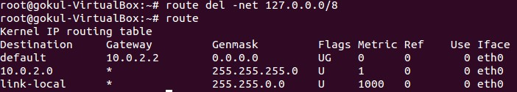

# Figure.1.10 Delete loopback address

4. Add/Remove a default gateway

In the below experiment, we will delete the default gateway and re­create it.

a. Delete the route for default gateway by the following the below figure.

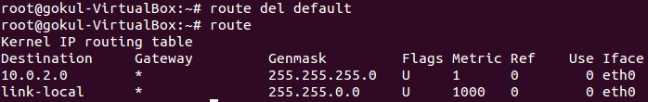

# Figure.1.11 Delete default gateway

b. Use your browser and connect to gmail.com (or any other web­site). There will be a connection error because default gateway is unavailable. The above can also be tested using a “ping” command as shown below.

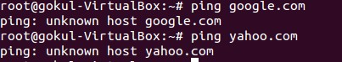

Figure.1.12 ping not working

# Add the default gateway back to its original value (172.16.4.1​ for IPC1 lab).​

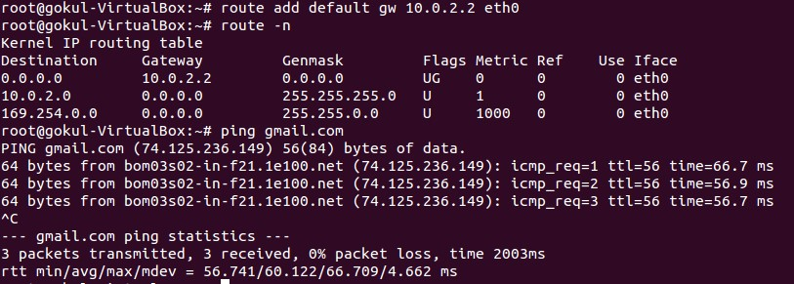

# Figure.1.13 Adding the default gateway

d. Use your browser and connect to gmail.com (or any other web­site). It should work fine.

**Analyse an internal network using Zenmap/nmap:**

Nmap (*Network*​ *Mapper*​) is a security scanner used to discover hosts and services on a computer network,​ thus creating a "map" of the network. To accomplish its goal, Nmap sends specially crafted packets​ to the target host and then analyzes the responses.​

The software provides a number of features for probing computer networks, including host discovery and service and operating system detection. These features are extensible by scripts that provide more advanced service detection,vulnerability detection, and other features. Nmap is also capable of adapting to network conditions including latency and congestion during a scan.​

Zenmap is the official Nmap Security Scanner GUI. It is a multi­platform (Linux, Windows, Mac OS X, BSD, etc.) free and open source application which aims to make Nmap easy for beginners to use while providing advanced features for experienced Nmap users. Frequently used scans can be saved as profiles to make them easy to run repeatedly. A command creator allows interactive creation of Nmap command lines. Scan results can be saved and viewed later. Saved scan results can be compared with one another to see how they differ. The results of recent scans are stored in a searchable database. The topology view in the Zenmap uses many symbols and color conventions.​

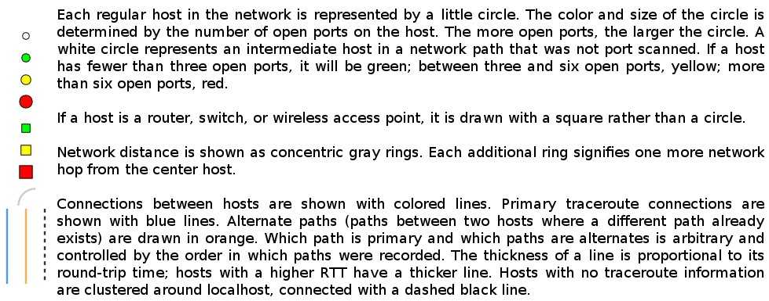

Tool used: Zenmap

**Experiment 2:**

1. Port Scanning: Performs a port­scan to check for open ports on the specified IP address range

Open zenmap and give the following details.

# Target: 172.16.5.0/27​

Command*:* nmap172*.*16*.5.0/27*

**Click “Scan”** button on the top right corner.​

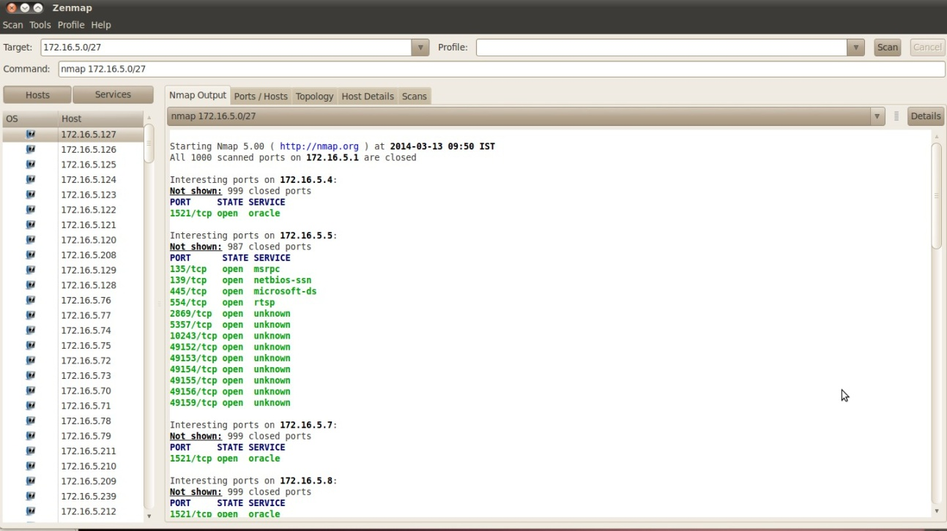

## Figure 2.1: port scan

a) Can you identify what ports are open on your neighbors’ system?

The below figure shows the network topology for the above scan (Click on the **Topology**​ tab).​

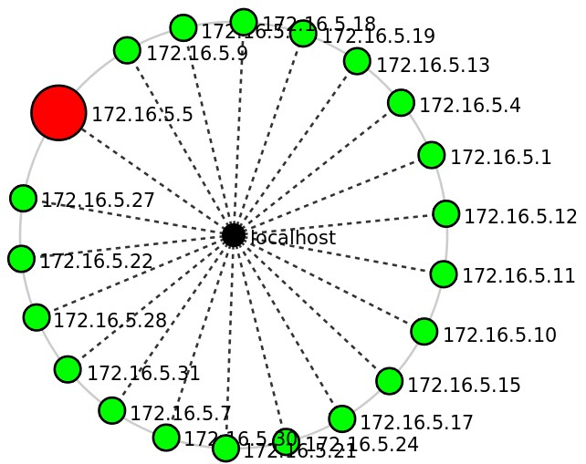

## Figure 2.2: Port scan Topology

a) What is your observation from the above topology?

2. Ping scan: Performs a Ping scan for the specified IP range. It can be used to figure out which machines are up and are responding to pings.

Give the following details in zenmap:

Target: 172.16.5.0/24

Command: choose the **ping scan**​ from the profile dropdown​

Click “Scan” button on the top right corner.

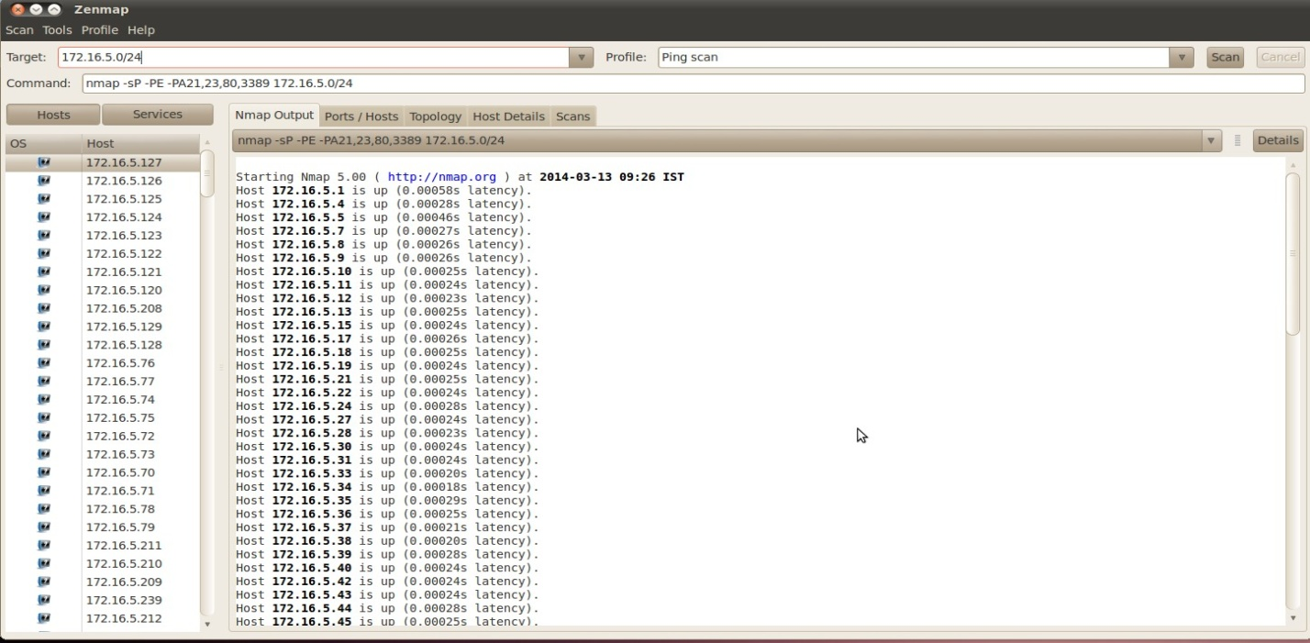

## Figure 2.3: Ping scan

3. Traceroute scan: Performs traceroute operation for specified IP addresses

(experiment with external IP’s ­ say 173.194.36.16/28)

Give the following details in zenmap:

Target: 172.16.5.0/24

Command: choose the **Quick traceroute**​ from the profile dropdown​

Click “Scan” button on the top right corner.

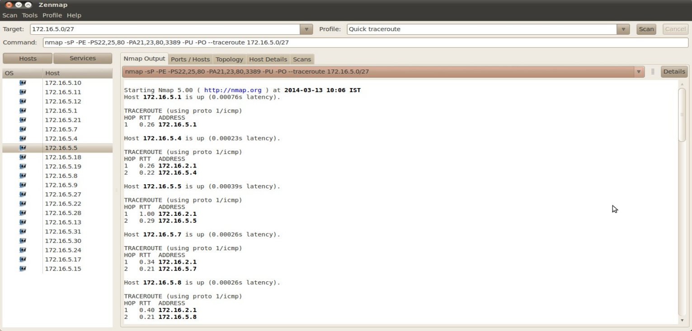

## Figure 2.4: Quick Traceroute

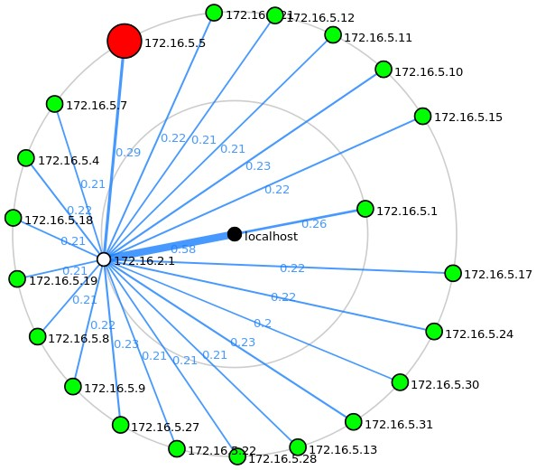

## Figure 2.5: Quick Traceroute Topology

4. Intense Scan: Enables OS detection, os version, script scanning and traceroute. This is considered as an “intrusive scan”. Give the following details in zenmap:

Target: 172.16.5.0/24

Command: choose the **intense scan**​ from the profile dropdown​ Click “Scan” button on the top right corner.

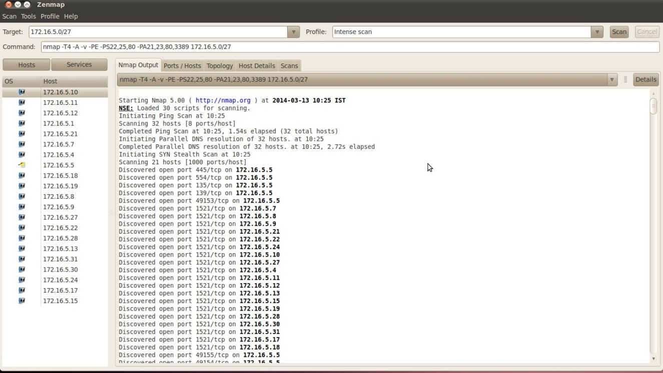Figure 2.6: Intense scan

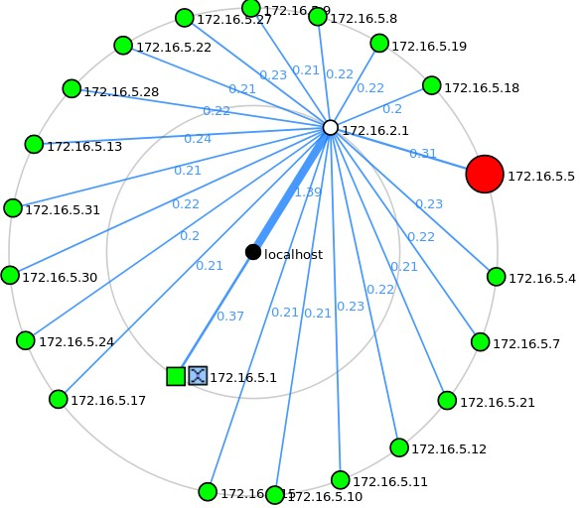

## Figure 2.7: Intense scan Topology

**Basic rule setting in iptables :-** iptables is a user space application program that allows a system administrator to configure the tables provided by the Linux kernel firewall (implemented as different Net filter modules) and the chains and rules it stores. Different kernel modules and programs are currently used for different protocols; *iptables*​ applies to IPv4, *ip6tables*​ to IPv6, *arptables*​ to ARP, and ​ *ebtables*​ ​ to Ethernet frames. iptables requires elevated ​privileges to operate and must be executed by user root,​ otherwise it fails to function. On most Linux systems, iptables is installed as /usr/sbin/iptables and documented in its man pages which can be opened using man iptables when installed. It may also be found in /sbin/iptables, but since iptables is more like a service rather than an "essential binary", the preferred location remains /usr/sbin.

# Tool used:​​iptables

**Experiment 3:**

1. To display firewall rule­set using iptables

a. Use “­L” option in “iptables” command. By default, “filter” table is displayed.

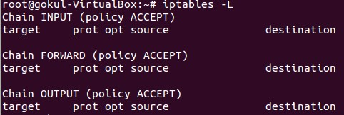

## Figure 3.1 Listing firewall rules

b. Explicitly the table can be specified using “­t” option.

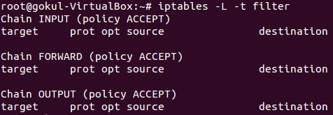

Figure 3.2 Listing firewall rules (using filter table)

2. To block gmail server, so that, your browser cannot open gmail.com.

1. Do a nslookup to find the IP addresses of gmail.com

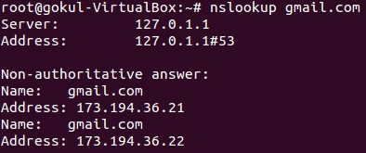

Figure 3.3 nslookup for gmail.com

There are two IP addresses associated with gmail.com. Block both the IP addresses.

1. Add a firewall rule for outgoing traffic. All TCP packets are not allowed to reach internet.



## Figure 3.4 Adding a firewall rule

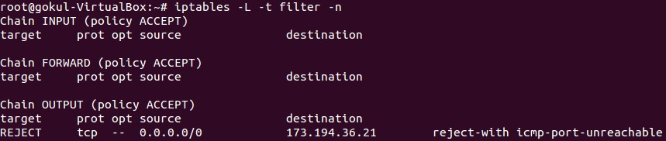

Figure 3.5 iptables showing added firewall rule

1. Similarly, add a firewall rule for rest of the IP addresses (Gmail server).
2. Open the browser and connect to gmail.com. What is the observation?
3. Do a ping to one of the IP addresses of Gmail.com. What is the observation?
4. Delete the above rules using “­D” option.



Figure 3.6 Delete a firewall rule

The above command will remove the first rule.

In a similar fashion, remove all the rules in the OUTPUT chain.

There is an option “­F” (flush) to remove rule­sets (“*iptables ­F”*​ ​ will remove all the rules).

3. To block all the outgoing packets to gmail.com

a. Add the firewall rule specified in the figure below.

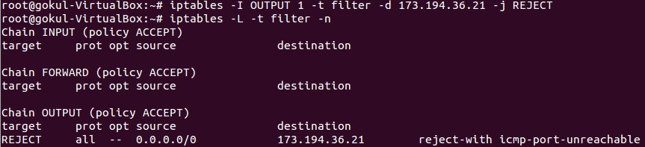

## Figure 3.7 Adding a firewall rule

1. Similarly, add rules for other IP addresses associated with gmail.com.
2. Do a ping for one of the IP addresses.

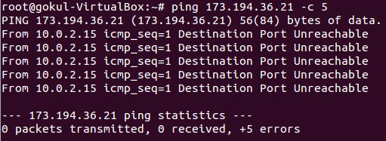

Figure 3.8 Testing with ping command

1. Delete the above rules using “­D” option.



## Figure 3.9 Delete the firewall rule

The above command will remove the first rule.

In a similar fashion, remove all the rules in the OUTPUT chain.

**Experiment-3**

**Aim: To learn about queue management techniques, and global routing in ns3**

Study the performance of **DropTail** and RED queue management techniques:

Tail Drop, or Drop Tail, is a very simple queue management algorithm used by Internet routers, e.g., in the network schedulers, and network switches to decide when to drop packets. In contrast to the more complex algorithms like RED and WRED, in Tail Drop the traffic is not differentiated. Each packet is treated identically. With tail drop, when the queue is filled to its maximum capacity, the newly arriving packets are dropped until the queue has enough room to accept incoming traffic**.**

The name arises from the effect of the policy on incoming datagrams. Once a queue has been filled, the router begins discarding all additional datagrams, thus dropping the tail of the sequence of datagrams. The loss of datagrams causes the TCP sender to enter slow start, which reduces throughput in that TCP session until the sender begins to receive acknowledgements again and increases its congestion window. A more severe problem occurs when datagrams from multiple TCP connections are dropped, causing global synchronization; i.e., all the involved TCP senders enter slow start. This happens because, instead of discarding many segments from one connection, the router would tend to discard one segment from each connection.

Random early detection (RED), also known as random early discard or random early drop is an queueing discipline for a network scheduler suited for congestion avoidance. RED monitors the average queue size and drops (or marks when used in conjunction with ECN) packets based on statistical probabilities. If the buffer is almost empty, all incoming packets are accepted. As the queue grows, the probability for dropping an incoming packet grows too. When the buffer is full, the probability has reached 1 and all incoming packets are dropped.

Experiment 1: Compare the performance of DropTail and RED queue techniques

1. Copy Red_vs_nlred.cc file from examples directory and put all .cc files into the scratch folder in ns3. 2. The Red_vs_nlred.cc code simulates the following network topology

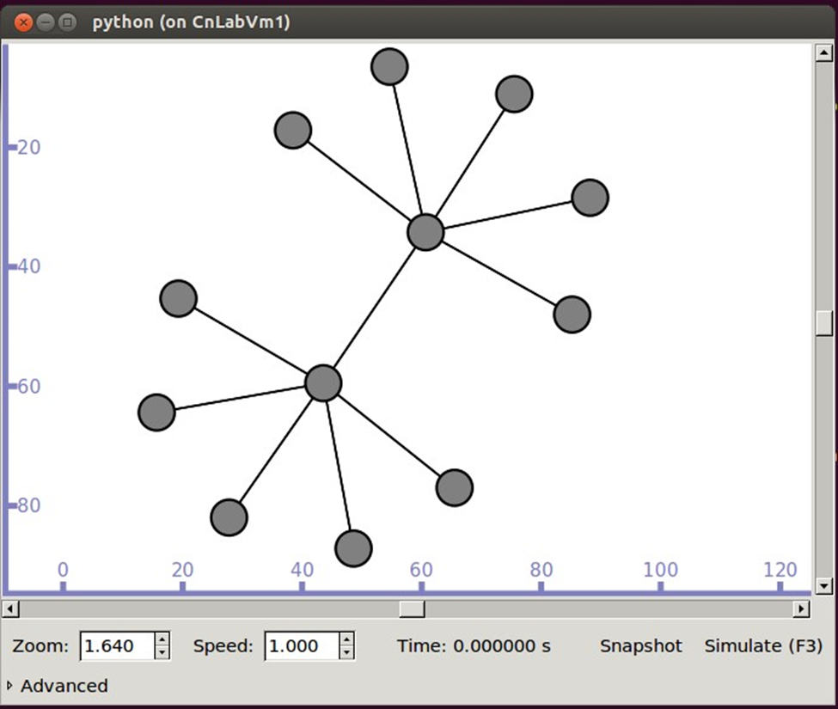

Figure.1. Topology

3. The bandwidth and delay of the bottleneck link is 1 Mbps and 50 ms. The data rate at the source nodes are higher than 1 Mbps. Since all traffic passes through a single route, there is a congestion in the network. This leads to drop in packets.

4. Copy the file to ns3_home_folder/scratch/ directory.

5. Open a terminal and navigate to ns3_home_folder.

6. Compile ns3 programs using the below command. ./waf

7. Run red_vs_nlred executable using the following command. ./waf --run Red_vs_nlred --vis

8. Simulator window will be opened on running the above command. Click “Simulate” button.

9. Wait for the simulation to complete. Once the simulation is completed, close the window.

10.The terminal will show the total no. of bytes received successfully at different destinations.

11.Create a new copy of droptail_vs_red.cc and change the queue to RED.

12.Run the experiment from step.4. to step.10.

13.Compare and contrast DropTail and RED queue techniques.

a. What is the total no. of bytes received in Droptail queue technique?

b. What is the total no. of bytes received in RED queue technique?

c. What is the inference?

**Experiment.2: Performance of RED for different link bandwidths and queue lengths**

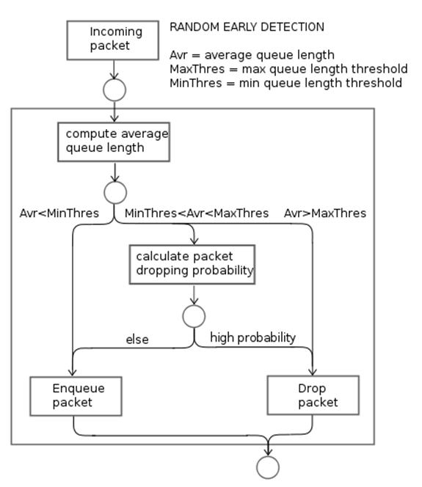

For a given network, the following parameters play a critical role in network congestion.

Traffic characteristics in source/destination hosts

1. Packet priority = Low, Medium, High

2. Traffic Type: Data, Voice, Video

3. Application Data Size: Distribution (Constant, Exponential, etc.), Application Data Size (1472 bytes, 512 bytes, etc.)

4. Inter Arrival Time: Distribution (Constant, Exponential, etc.), Mean Inter Arrival Time (micro seconds)

Link Properties

1. Distance (km)

2. Bit Error Rate (BER)

3. Physical Medium (CAT510 Mbps, E2, etc.)

Router properties:

1. Buffer size (KB): 8, 16, 32, etc.

2. Scheduling Type: FIFO, Priority

3. Queue Technique: DropTail, RED

**Steps in the experiment:**

1. The code simulates the following network topology.

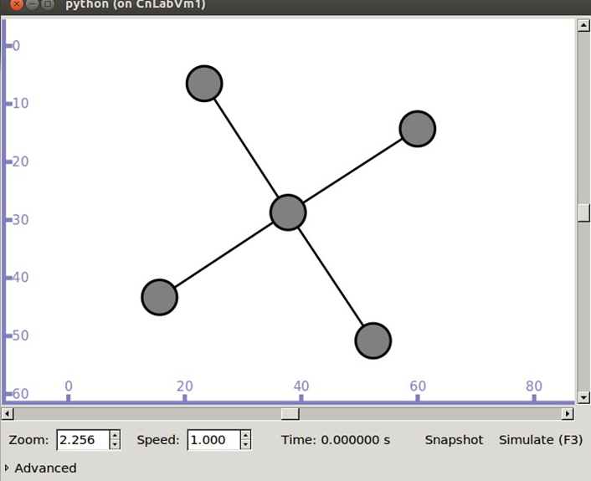

Figure. 2. Topology

2. The bandwidth and delay of the bottleneck link is 10 Mbps and 10 ms. The traffic at source and destinations are 8 Mbps, 5 Mbps, and 7 Mbps. Since, there are many sources passing through a single route (as shown in the above figure), there is a huge drop in packets.

3. Copy the file to ns3_home_folder/scratch/ directory.

4. Open a terminal and navigate to ns3_home_folder.

5. Compile ns3 programs using the below command. ./waf

6. Run redqueue executable using the following command ./waf run RedQueueStats vis

7. Simulator window will be opened on running the above command. Click “Simulate” button.

8. Wait for the simulation to complete. Once the simulation is completed, close the window.

9. The terminal will show the total no. of dropped packets. The following information is displayed.

a. Packets drop after crossing avg. threshold level (High prob.)

b. Packets drop after crossing max. threshold level (QueueAvg > MaxQueue)

c. Packets drop after crossing the queue length (Queue is full)

10.Change the bandwidth of the bottleneck link to 15 Mbps. Compile the code and run the experiment.

a. What is your observation for step.9

11.Change the bandwidth of the bottleneck link to 20 Mbps. Compile the code and run the experiment.

a. What is your observation for step.9

12.From the steps 9, 10, and 11

a. What is the inference?

b. What is the minimum and maximum threshold value?

13.Change the bandwidth of the bottleneck link to 2 Mbps. Default values of MinThreshold , MaxThreshold and QueueLimit are 5, 15 and 25. Change MinThreshold less than 5 and MaxThreshold less than 15. Compile the code and run the experiment.

a. What is your observation for step.9

**Analyse the effect of broken links on routing table:**

Routing is the process of selecting best paths in a network. In the past, the term routing was also used to mean forwarding network traffic among networks. However, this latter function is much better described as simply forwarding. Routing is performed for many kinds of networks, including the telephone network (circuit switching), electronic data networks (such as the Internet), and transportation networks.

In packet switching networks, routing directs packet forwarding (the transit of logically addressed network packets from their source toward their ultimate destination) through intermediate nodes. Intermediate nodes are typically network hardware devices such as routers, bridges, gateways, firewalls, or switches. General purpose computers can also forward packets and perform routing, though they are not specialized hardware and may suffer from limited performance. The routing process usually directs forwarding on the basis of routing tables which maintain a record of the routes to various network destinations. Thus, constructing routing tables, which are held in the router's memory, is very important for efficient routing

When applying link state algorithms, a graphical map of the network is the fundamental data used for each node. To produce its map, each node floods the entire network with information about the other nodes it can connect to. Each node then independently assembles this information into a map. Using this map, each router independently determines the least cost path from itself to every other node using a standard shortest paths algorithm such as Dijkstra's algorithm.

**Experiment.3: Dynamic Global Routing**

We will examine global routing in a mixed environment with Point to Point links and CSMA/CD channel.

Copy the dynamic_global_routing.cc file from examples into scratch folder.

The following topology is created:

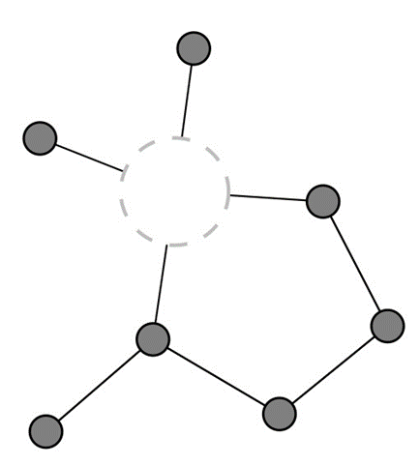

1. Run the simulation from ns3 home folder

a. ./waf

b. ./waf run globalrouting (use ‘vis’ to enable visualization)

2. Data is transferred from n1 to n6. Identify n1 and n6 correctly from the visualization.

3. At pre simulation time, global routes configured. Look for the following line in the code: aa a.Ipv4GlobalRoutingHelper::PopulateRoutingTables ();

4. The shortest path from n1 to n6 is via the direct pointtopoint link. This will be the default choice.

5. At time 1s, CBR traffic flow from n1 to n6 is started

6. At time 2s, the n1 pointtopoint interface goes down. Through what path will the packets get diverted?

a. Under what other circumstances (apart from the interface going down) could the path of the packets dynamically change?

7. At time 4s, the n1/n6 interface is reenabled to up. Now what will be the path taken by the packets between n1n6?

8. At time 6s, the n6-n1 pointtopoint Ipv4 interface is set to down (note, this keeps the pointtopoint link "up" from n1's perspective). Observe the change of path of the packets (NOTE: observe the visualization as well as the corresponding pcap files)

9. At time 8s, the interface comes up. The older path is restored.

10.At time 10s, the first flow is stopped.

11.At time 11s, a new flow started, but to n6's other IP address (the one on the n1/n6 p2p link)

12.At time 12s, the n1 interface down between n1 and n6 is put down. Packets will be diverted to the alternate path

13.At time 14s, the n1/n6 interface is reenabled. This will change routing back to n1n6 since the interface up notification will cause a new local interface route, at higher priority than global routing

14.At time 20s, the second flow stopped and simulation ends.

**Experiment-4**

**Aim: To learn about broadcasting, multicasting, and bridging in a Local AreaNetwork using ns-3.**

First remove old .cc files from your scratch folder. Copy first.cc and second.cc from

examples->Tutorial into scratch folder.

**Carrier Sense Multiple Access (CSMA)**

Carrier Sense Multiple Access/Collision Detect (CSMA/CD) is the protocol for carrier transmission access in Ethernet networks. On Ethernet, any device can try to send a frame at any time. Each device senses whether the line is idle and therefore available to be used. If it is, the device begins to transmit its first frame. If another device has tried to send at the same time, a collision is said to occur and the frames are discarded. Each device then waits a random amount of time and retries until successful in getting its transmission sent.

**Experiment 1:** One Point-to-Point link with one CSMA channel with four nodes

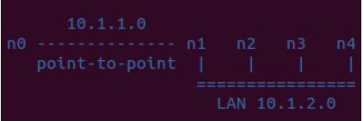

Figure.1. Default LAN Topology

In *p oint2point-csma.cc* file you have the topology as given above. This program builds a one point-to-point channel from *n 0* to one LAN segment over csma channel. But when you run *point2point-csma. cc* program, ns3does not visualize it in the same way. The visualization by ns-3looks like the figure below.

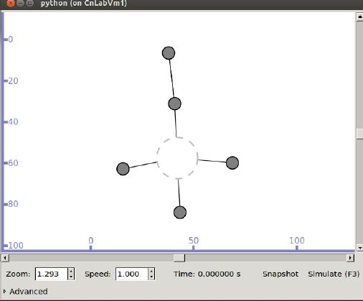

Figure.2. Simulation of LAN Topology

In the figure above, the dotted circle in the center is the CSMA channel. The top

most node is *n0*.

Pcap captures for the simulation are enabled by default.

1. Do you see ARP communication in the Point-to-Point link?

2. What about the CSMA LAN?

Write down your observations.

For the experiment above, extend it to create the topology given below:

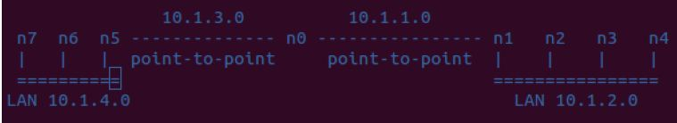

Figure.3. Topology2

**Experiment 2:** IP broadcasting over two CSMA channels

Open the IpBroadcastCSMA.cc file. It uses the following topology:

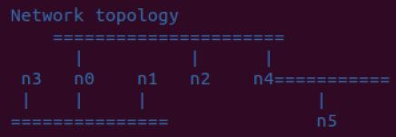

Figure.4. Default Broadcast Topology

In the figure below, *n0* is the node in the middle of the two CSMA channels. *n0* originates UDP broadcast to specified LAN segment. In the IpBroadcastCSMA.cc file, line 101 has OnOffHelper which takes the IP address as a parameter. The code given to you has 1 0.1.3.255 as the IP address, which is the broadcast IP of the CSMA channel at the bottom in the given figure. If you want *n0* to broadcast to both CSMA channels, comment out line 101 and uncomment line 103. This will make the broadcast IP as 255.255.255.255 .

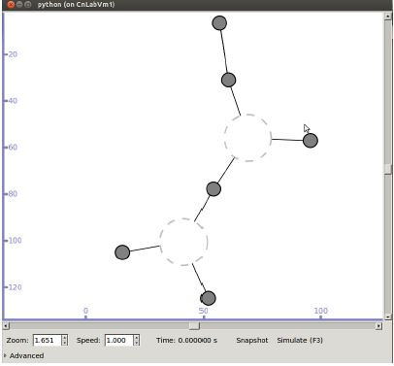

Figure.5. Simulation of Broadcast Topology

Write down your observations.

**Experiment 3** : IP multicasting over two CSMA channels

Open IpMulticastCSMA.cc file. It uses the following topology.

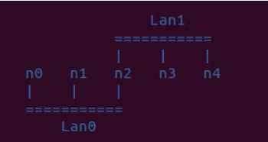

Figure.6. Default Multicast Topology

As given in line 101 of the code, *n0* is the multicast source

Ipv4Address multicastSource(“10.1.1.1”)

This topology is similar to the previous one. *n2*is the node in the middle of the two CSMA channels.

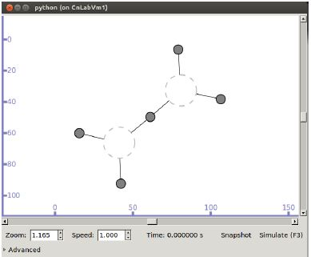

Figure.7. Simulation of Multicast Topology

Change the multicast source node to *n3* . Send multicast data to nodes *n0, n1* , and *n4* .

Write down your observations.

**Experiment 4:** Bridging over CSMA and with one intermediate router

Open BridgingOneHop.cc file. It uses the following topology.

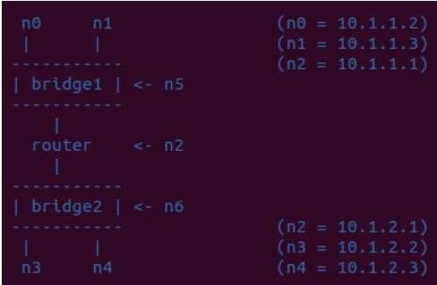

Figure.8. Default Bridging Network

In the figure below, *n2* is the router node in the middle. Application data is transmitted from *n0* to *n1* and from *n3* to *n0*. The Data rate for n0>n1 transmission is 500Kb/s (see line 165 of code), and Data rate for n3>n0 transmission is 100Kb/s (see line 181 of code).

In the figure below, *n2* is the router node in the middle. Application data is transmitted from *n0* to *n1* and from *n3* to *n0*. The Data rate for n0>n1 transmission is 500Kb/s (see line 165 of code), and Data rate for n3>n0 transmission is 100Kb/s (see line 181 of code)

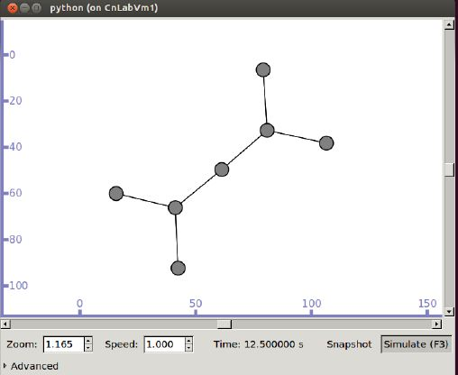

Figure.9. Simulation of Bridging Network

This shows two broadcast domains, each interconnected by a bridge with a router node interconnecting the Layer2 broadcast domains.

While running the simulation, observe the ‘interface statistics’ (right click on the node) for n0 and the bridging node n5. Can you observe ‘IPv4 Routing Table’ for the bridging nodes (n5 and n6)?

Write down your observations.

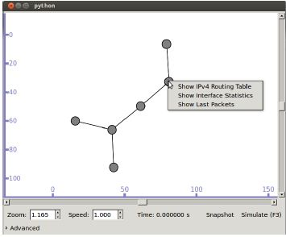

Figure.10. Observing Node statistics

At n5, we can observe the following statistics:

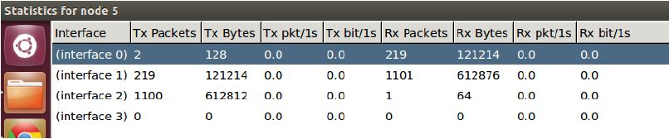

Figure.11. Statistics for node 5

The Received bytes at interface 1 are maximum. Can you correctly identify interface 1 of node 5 on your visualization? Can you identify its interface 2 as well? Why does interface 3 has no Transmitted or Received bytes?

Write down your observations.

Experiment-5

# Aim: To learn about Wi­fi and Mobile Ad­hoc topologies with ns­3.

IEEE 802.11 wireless LANs use a media access control protocol called Carrier Sense Multiple Access with Collision Avoidance (CSMA/CA).

Wi­Fi systems are half duplex shared media configurations, where all stations transmit and receive on the same radio channel. The fundamental problem this creates in a radio system is that a station cannot hear while it is sending, and hence it is impossible to detect a collision. Because of this, the developers of the 802.11 specifications came up with a collision avoidance mechanism called the Distributed Control Function (DCF).

According to DCF, a Wi­Fi station will transmit only if it thinks the channel is clear. All transmissions are acknowledged, so if a station does not receive an acknowledgement, it assumes a collision occurred and retries after a random waiting interval.

**Experiment 1:**

1. third.cc file in examples folder creates the following topology:

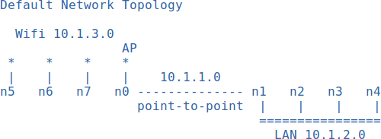

In ns­3, the visualization will appear similar to the figure below:

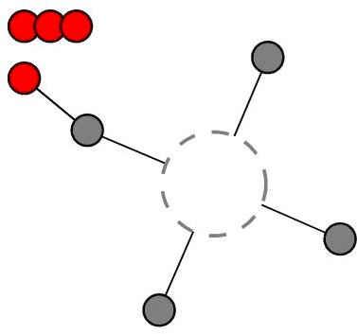

You may increase the number of Wi­fi devices by specifying it at run­time in the following manner:

./waf ­­run 'wifi­example ­­nWifi=10' ­­vis

(18 is the hard­coded upper limit)

You may observe the pcap files generated at different nodes. Packet captures are enabled in the line numbers 172­174 of the code:

pointToPoint.EnablePcapAll ("wifi­p2p");

phy.EnablePcap ("wifi­ap", apDevices.Get (0));

csma.EnablePcap ("wifi­csma", csmaDevices.Get (0), true);

Since no data applications are enabled, you do not see any data in the pcap files apart from broadcast messages by the Wi­fi A.P. In pcap files generated at the A.P., can you observe the beacon frames and acknowledgements?

1. Create a UDP Echo Client­Server application for the above topology. The last node on the CSMA LAN should be your Echo Server. Configure any of the Wi­fi devices as your Client.

Comment out line number 152­166 to implement the above. Observe UDP server port number and other client attributes.

After running the Echo Client­Server application, observe the fresh pcap files generated.

## Experiment 2: Extending the previous topology

Extend the above topology so as to create a Wi­fi Access Point on one of the CSMA LAN nodes. Connect three Wi­fi nodes to this Access Point as shown in the figure below:

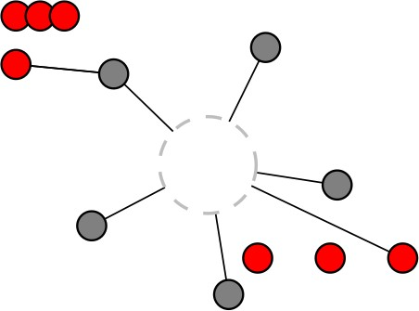

Some hints to help you extend the topology:

* + Do not install the Internet stack twice on any node.
  + Remember to give your new Wi­fi Access Point a SSID which is different from the previous one.
  + The Wi­fi devices and their Access Point must be in the same IP subnet.
  + In order to have your new Wi­fi nodes physically apart from the old nodes, you will need to set appropriate values for the SetPositionAllocator method of the MobilityHelper class.

1. Further, modify your UDP Echo Server­Client application by configuring the Server as a Wi­fi device on the new A.P.. (Hint: the present code will not suffice for this implementation because the Wi­fi devices have no ‘IPv4Interface’ associated with them)
2. The final topology will look like the figure below:
3. 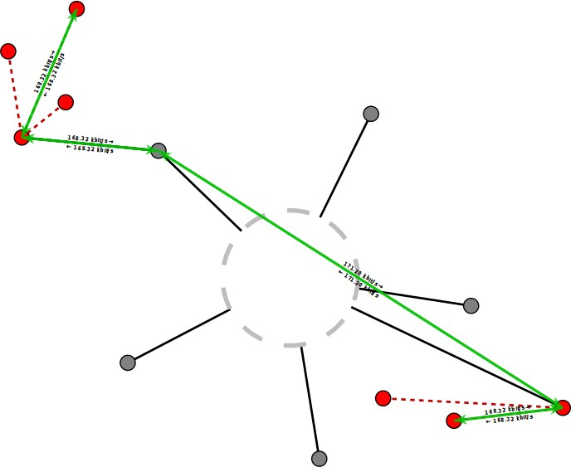
4. Observe the fresh pcap files generated. You should be able to see data transfer between the two Wi­fi devices.

## AODV (Ad­hoc On­Demand Distance Vector)

Ad hoc On­Demand Distance Vector (AODV) Routing is a routing protocol for mobile ad hoc networks (MANETs) and other wireless ad hoc networks.

The AODV Routing Protocol uses an on­demand approach for finding routes, that is, a route is established only when it is required by a source node for transmitting data packets. It employs destination sequence numbers to identify the most recent path. In AODV, the source node and the intermediate nodes store the next­hop information corresponding to each flow for data packet transmission. In an on­demand routing protocol, the source node floods the RouteRequest packet in the network when a route is not available for the desired destination. It may obtain multiple routes to different destinations from a single RouteRequest. The major difference between AODV and other on­demand routing protocols is that it uses a destination sequence number (DestSeqNum) to determine an up­to­date path to the destination. A node updates its path information only if the DestSeqNum of the current packet received is greater or equal than the last DestSeqNum stored at the node with smaller hopcount.

## Experiment 3: Understanding the AODV routing protocol for Mobile adhoc networks

The My_aodv.cc file generates a topology of 12 mobile nodes, 4 in each line.



The nodes are separated by a distance ‘step’ specified in the code. The initial value given to ‘step’ is 100m. The step variable can be varied from 80 to 120. As the ‘step’ size increases, you will observe that neighboring nodes are not able to communicate to each other directly (the link between then breaks).

Thus the nodes will use AODV routing to figure out alternate routing paths. Observe the

aodv.routes file, which gives the AODV routing table at each node.

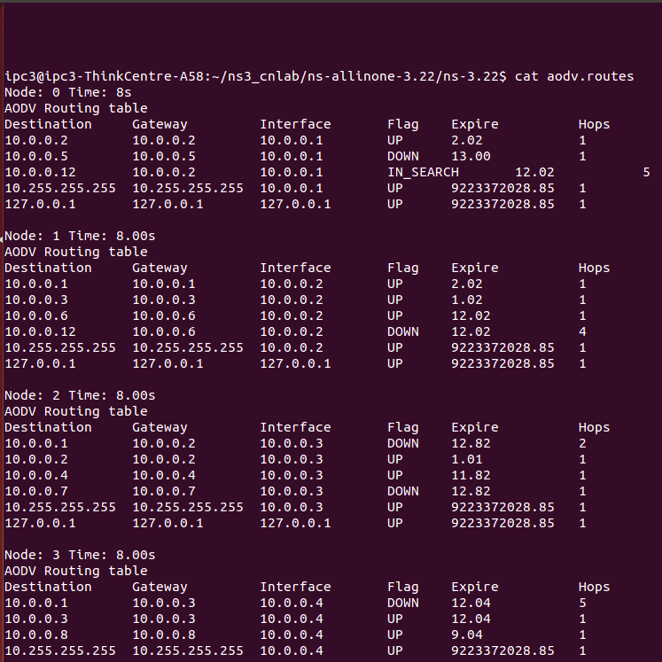

**References**

1. <http://www.nsnam.org/> [http://en.wikipedia.org/wiki/Wi­Fi](http://en.wikipedia.org/wiki/Wi-Fi)

**Experiment-6**

**AIM:-To Introduce Socket Programming in TCP and UDP**

**TCP Socket Programming:**

A socket is the mechanism that most popular operating systems provide to give programs access

to the network. It allows messages to be sent and received between applications

(unrelated processes) on different networked machines. The sockets mechanism has

been created to be independent of any specific type of network.

A socket address is the combination of an IP address and a port number, much like one end

of a telephone connection is the combination of a phone number and a particular extension.

Based on this address, internet sockets deliver incoming data packets to the

appropriate process or thread.

An Internet socket is characterized by a unique combination of the following:

1. Local socket address: Local IP address and port number
2. Remote socket address: Only for established TCP sockets. This is necessary since a TCP server

may serve several clients concurrently. The server creates one socket for each client, and

these sockets share the same local socket address from the point of view of the TCP server.

1. Protocol: A transport protocol (e.g., TCP, UDP, raw IP, or others). TCP port 53 and UDP port

53 are consequently different, distinct sockets.

**Tools used**: gedit, terminal

# Experiment 1: Working of a TCP concurrent server

1. Create “tcp_client.c” and “tcp_server.c”.
2. Compile server first (as shown below). gcc -o server tcp_server.c
3. Similarly, compile the client using the following command. gcc -o client tcp_client.c
4. Run the server using the below command. After running, the server would wait for an

incoming connection (as shown in the Figure.1)

**./server**



Fig1. Server waiting for connections

5.On separate terminal window, run the client using

**./client ​*<server IP or localhost>***



Fig2. Client waiting for User input

6.Enter a character as input and it will be echoed back by the server (Refer Figure.3)

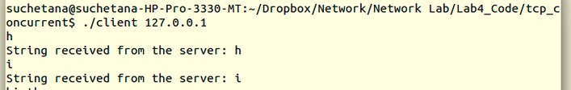

Fig3. Client input-output

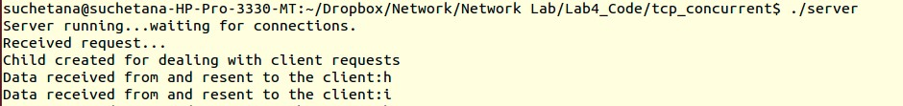

Fig4. Server output

7.To stop the server and client, click “Ctrl +C” in their respective terminals. (To start the server again, wait for a couple of seconds).

# Experiment 2: Modification of the TCP Client-Server programs

1. Download “tcp_client.c” and “tcp_server.c” from the CMS Website
2. Modify the filenames as “tcp_client_n.c” and “tcp_server_n.c”
3. Modify the program such that the client sends a string as a message to the server. Make sure the server echoes back the same string. (Hint: use buffer to handle the string exchanges by server-client and modify read and write functions).
4. Compile server first (as shown below). gcc -o server_ntcp_server_n.c
5. Similarly, compile the client using the following command. gcc -o client_ntcp_client_n.c
6. Run the server using the below command.

**./server_n**

1. The server will start, waiting for a client to connect. On a separate terminal window, run the client using

**./client_n ​*<server IP or localhost>***

1. Type “hi I am client!” in the client terminal window. As you see the figure.6, the same message is echoed back from the server.

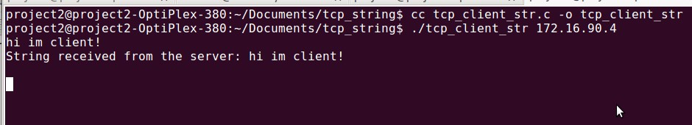

Fig5. Client sending string

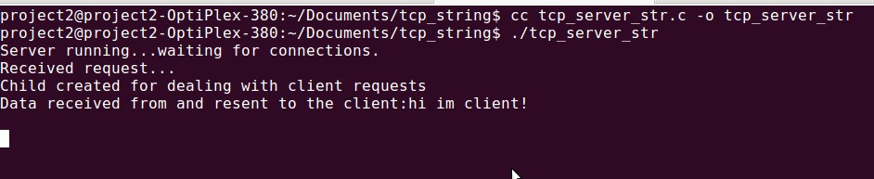

Fig6: Server receiving String

1. To stop the server and client, click “Ctrl +C” in their respective terminals. (To start the server again, wait for a couple of seconds).

**Questions**

Answer the following questions based on your understanding of the experiments.

1. Which field in the ​*socket* function specifies the type of transport layer protocol (like TCP, UDP, etc.)?
2. What is the IP address and port no. of the server?
3. What is the purpose of bind function?
4. Which of the functions mentioned below are blocking calls?
   1. socket
   2. connect
   3. bind
   4. listen
   5. accept
   6. send
   7. recv
   8. close

5. Which function in the client program involved in connection establishment?

6. Which function in the server program involved in connection establishment?

1. send and recv functions are analogous to writing to a file and reading from a file. (T/F)
2. What is a concurrent server?

**UDP Socket Programming:**

A datagram socket is a type of connectionless network socket, which is the sending or receiving point for packet delivery services. Each packet sent or received on a datagram socket is individually addressed and routed. Multiple packets sent from one machine to another may arrive in any order and might not arrive at the receiving computer.

A datagram socket provides a symmetric data exchange interface without requiring connection establishment. Each message carries the destination address.

**Tools used**: gedit, terminal

# Experiment 3: Working of an UDP Client-Server program

1. Download “udp_client.c” and “udp _server.c” from the CMS Website.
2. The programs are partially complete. Complete the rest of the program, so that, it compiles and runs successfully (Implement echo server described in Experiment.2.)
3. Compile server first (as shown below). gcc -o udp_serverudp_server.c
4. Similarly, compile the client using the following command. gcc -o udp_clientudp_client.c
5. Run the server using the below command.

./udp_server

1. The server will start, waiting for a client to connect. On a separate terminal window, run the client using

./udp_client ​*<server IP or localhost>*

1. Enter a character as input and it will be echoed back by the server (Refer Figure.7)

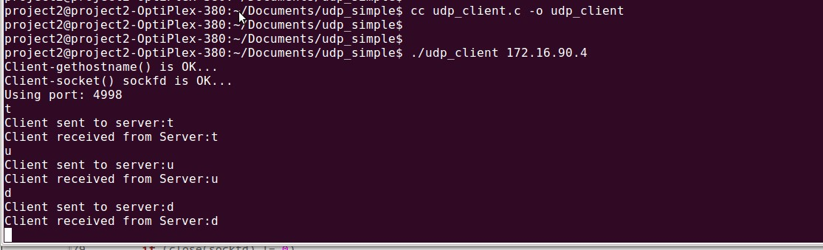

Fig7: Client sending and receiving a character

1. To stop the server and client, click “Ctrl +C” in their respective terminals. (To start the server again, wait for a couple of seconds).

# Experiment 4: Modification of the UDP Client-Server programs

1. Download “udp_client.c” and “udp_server.c” from the CMS Website
2. Modify the filenames as “udp_client_n.c” and “udp_server_n.c”
3. Modify the program such that the client sends a string as a message to the server. Make sure the server echoes back the same string. (Hint: use buffer to handle the string exchanges by server-client and modify read and write functions).
4. Compile server first (as shown below). gcc -o udp_server_nudp_server_n.c
5. Similarly, compile the client using the following command. gcc -o udp_client_nudp_client_n.c
6. Run the server using the below command.

./udp_server_n

1. The server will start, waiting for a client to connect. On a separate terminal window, run the client using

./udp_client_n ​*<server IP or localhost>*

1. Type “hello” in the client terminal window. As you see the Figure.8, the same message is echoed back from the server.

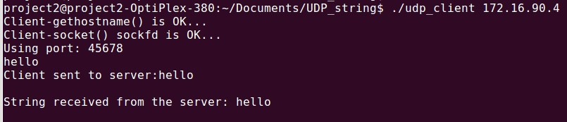

Fig8: Client sending and receiving a string

1. To stop the server and client, click “Ctrl +C” in their respective terminals. (To start the server again, wait for a couple of seconds).

Questions

Answer the following questions based on your understanding of the experiment.

1. Order the sequence of operations in an UDP socket communication.

|  |  |
| --- | --- |
| Client functions | Server functions |
| Close | Close |
| Socket | Socket |
| Sendto | Sendto |
| Recvfrom | Recvfrom |
|  | Bind |

1. What is the difference between UDP and TCP echo servers?

# References

➢ Unix Manual: http://man7.org/linux/man-pages/man2/socket.2.html

Experiment-7

# Aim: Observations of Transmission Control Protocol (TCP) Connection states, Flags and Flow control.

**TCP Connection States:**

TCP protocol operations may be divided into three phases. Connections must be properly established in a multi-step handshake process (*connection establishment*) before entering the data transfer phase. After *data transmission* is completed, the *connection termination* closes established virtual circuits and releases all allocated resources.

A TCP connection is managed by an operating system through a programming interface that represents the local end-point for communications, the Internet socket. During the 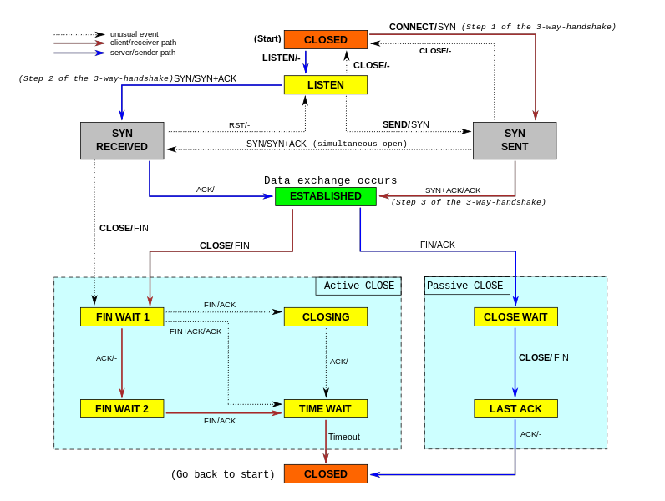

Fig.1: TCP State Diagram

lifetime of a TCP connection the local end-point undergoes a series of state changes:

Tools used: Wireshark, netstat.

# Experiment 1: Observation of TCP connection states

1. Download “tcp_client.c” and “tcp_server.c” from the CMS Website
2. Compile server first (as shown below).

gcc -o tcp_server tcp_server.c

1. Similarly, compile the client using the following command.

gcc -o tcp_client tcp_client.c

1. Run the server using the below command.

./tcp_server

1. The server will start, waiting for a client to connect. On a separate terminal window, run the client using

./tcp_client <IP address of your neighbour>

1. Enter a character as input and it will be echoed back by the server. Use netstat to check the TCP connection state in client PC and server PC separately.
   1. What is the connection state in the client machine?
   2. What is the connection state in the server machine?
2. Stop client and server programs. Immediately, start the server again.
   1. What is the observation?
3. Connection Establishment states (LISTEN, SYN_SENT, SYN_RCVD)
   1. LISTEN state

Start the server in your neighbor PC.

* + 1. What is the TCP connection state (observed using netstat)?

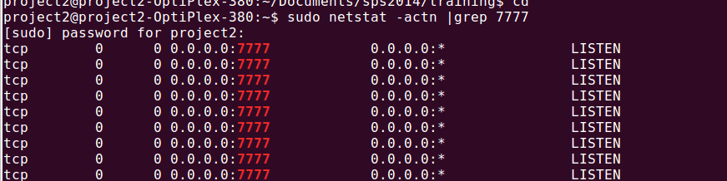

Fig. 2: LISTEN state on Server side

1. Connection Termination states
   1. FIN_WAIT2 state and CLOSE_WAIT state

Server or Client does close (CTRL+C)

* + 1. What is the connection state in the client machine?
    2. What is the connection state in the server machine?

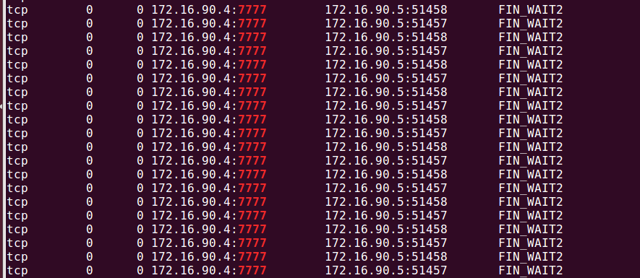

Fig. 3: FIN_WAIT2 state on Server side (172.16.90.4)

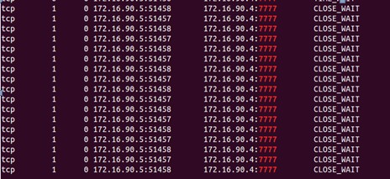

Fig. 4: CLOSE_WAIT state on Client side (172.16.90.5)

a).TIME_WAIT

Connect to the Server with two (or more clients). Stop the server program (normal close). Server goes to FIN_WAIT2. Then, terminate your client programs.

* + 1. Now, what is the connection state in the Server machine? 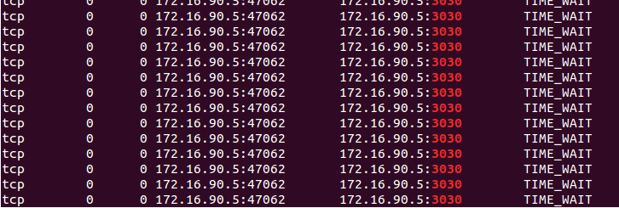Fig. 5: TIME_WAIT state at Server
  1. FIN_WAIT1

Terminate the server while the client is still receiving data from the server (HINT: sending a single character will not give such behavior. You will need to send lot more data). FIN_WAIT1 state will observed at server.

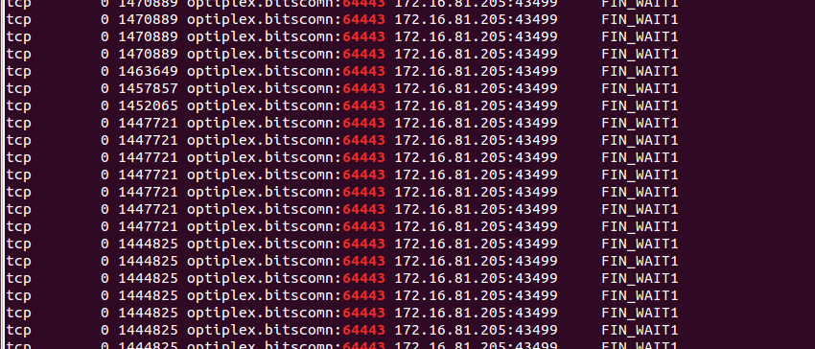

Fig. 6: FIN_WAIT1 at Server

1. Reset Connection

Try sending data to Server when it has been terminated. RST packet is transmitted to client.

* 1. Find the RST packet in Wireshark (Refer Figure 7 below)

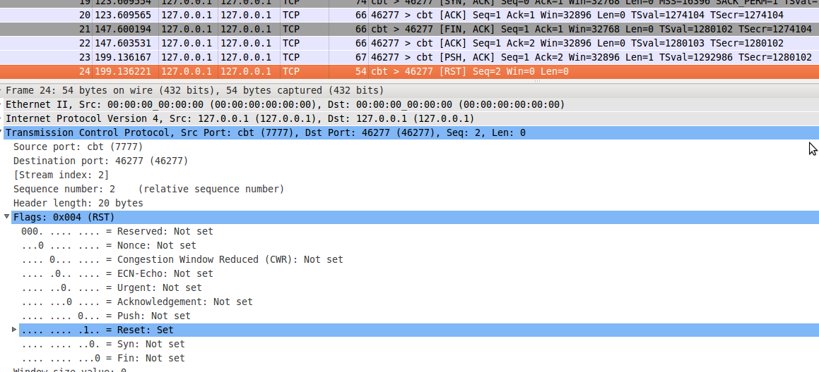

Fig. 7: Packet from Server (on port 7777) to client (on port 46277) with RST flag set

1. The Use of PUSH Flag
   1. Observe the data packets. Since, the amount of data is too low (1 byte) the TCP uses PUSH protocol to send the data. Figure 8 shows the PUSH flag being set in the TCP packet (TCP Flags)

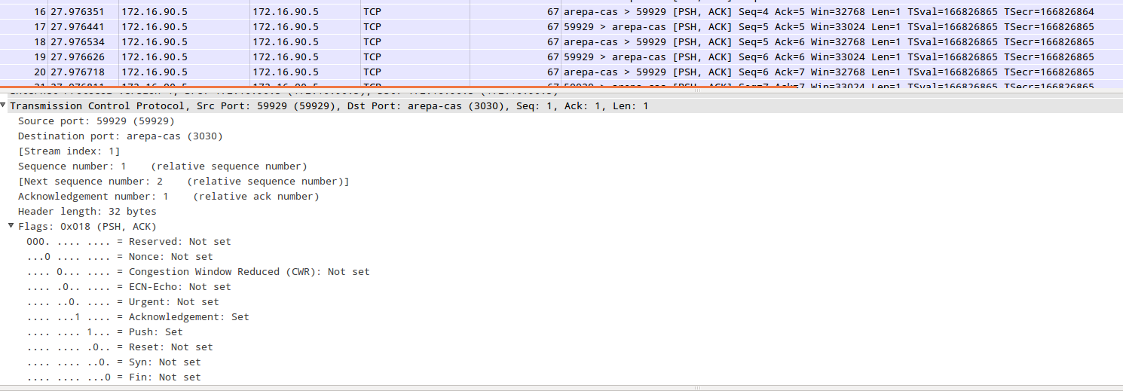

Fig. 8: Use of PSH to send data

# TCP Header Fields:

The Transmission Control Protocol (TCP) is one of the core protocols of the Internet protocol suite (IP), and is so common that the entire suite is often called TCP/IP. TCP provides reliable, ordered, error-checked delivery of a stream of octets between programs running on computers connected to a local area network, intranet or the public Internet. It resides at the transport layer.

Tool used: Wireshark

# Experiment 2: Observation of fields in a TCP packet header

1. Close all the browsers.
2. Run Wireshark in non-promiscuous mode with root privileges.
3. Open the website [http://lbrce.ac.in/](http://www.bits-pilani.ac.in/) in a browser window.
4. Stop Wireshark and observe the packets.

How to differentiate a control packet and a data packet?

1. Connection Establishment packets
   1. Find the SYN packet in the TCP flow. The below diagram (Figure 9, see packet number 6) shows the TCP SYN flag set as in a Wireshark window.

Who sends the SYN packet?

What is the HLEN value for the SYN message?

[5](http://wiki.wireshark.org/)

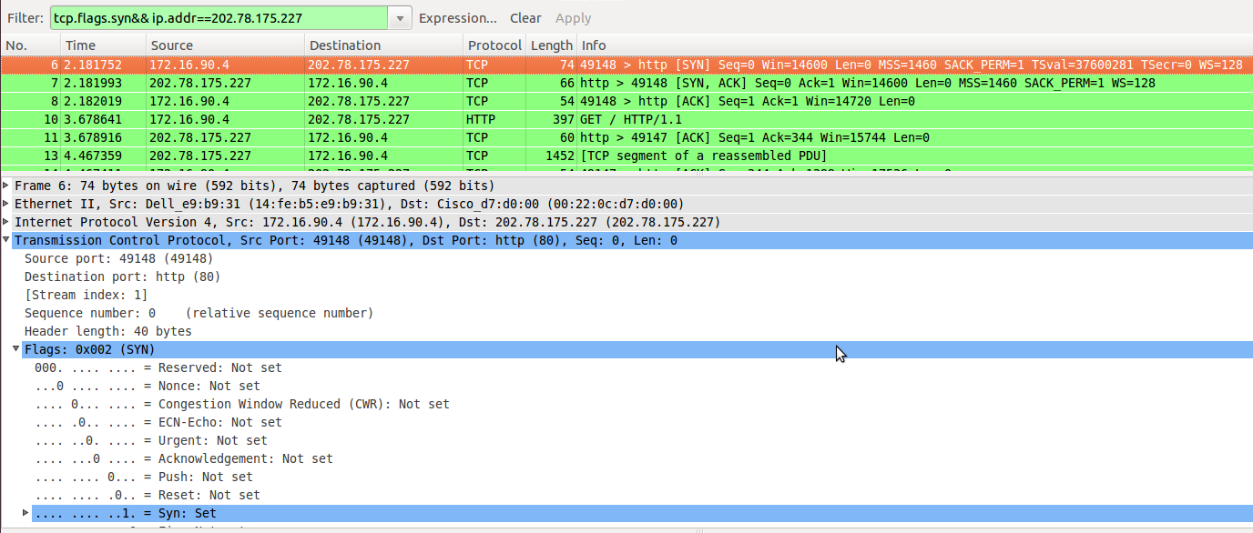

Fig. 9: SYN/ SYN-ACK /ACK packets

1. Find the SYN-ACK packet in the TCP flow. The above diagram (Figure 9, see packet number 7) shows the SYN-ACK packet.

Who sends the SYN-ACK packet?

Find the first ACK packet from the server (the website). The below diagram (Figure 10) shows the TCP flags as in a Wireshark window.

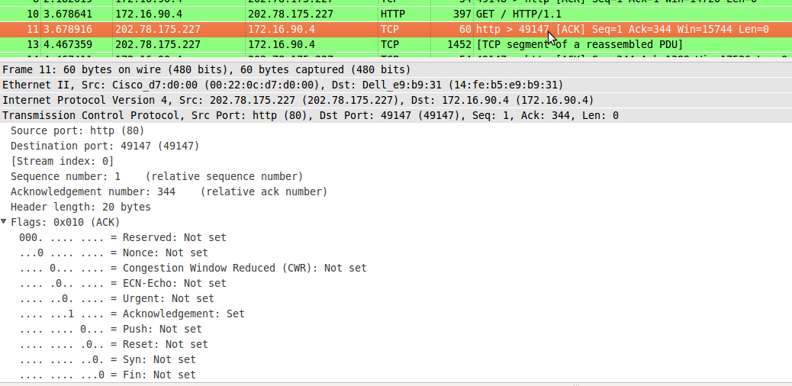Fig. 10: Data ACKed by Server

1. Check if the last ACK in connection establishment (SYN-SYN ACK-ACK) is piggy backed with data packets?
2. Connection Termination packets
   1. Find the FIN packet in the TCP flow.
   2. Find the ACK or FIN-ACK packet from the server (the website).
   3. The below diagram (Figure. 11) shows the TCP FIN flags as in a Wireshark window.

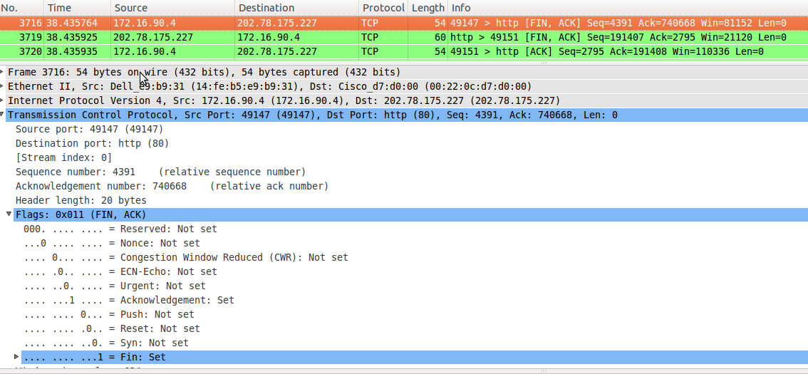Fig. 11: Connection termination with FIN flags

1. Urgent flag
   1. In the Wireshark capture of your Client-Server module, find the packet(s) with Urgent flag set. (Figure 12)

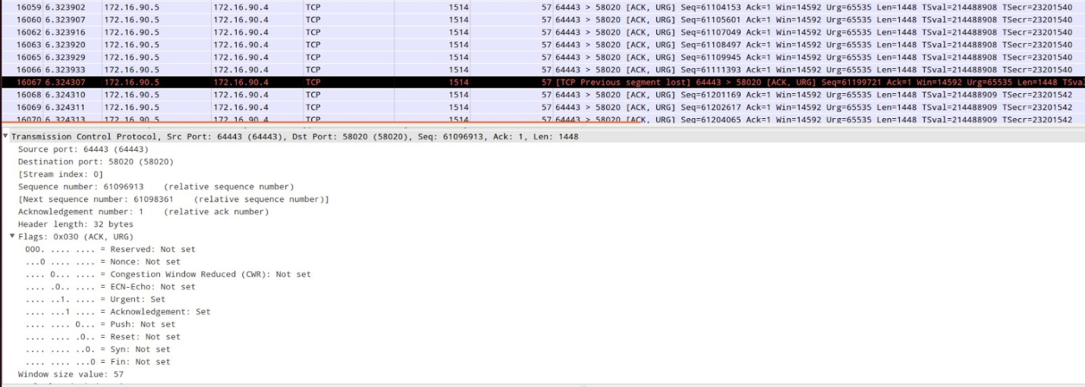

Fig. 12: URG flag set

1. Source port/Destination Port

The below figure (Figure. 13) shows the source port and destination port of a packet that travels from the web browser to the server.

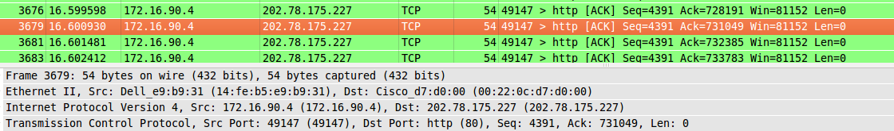

Fig. 13: Source port= 49147, Destination port= 80

* 1. Does the destination port number change for all packets from a client to a server?
  2. For a given connection, will the source port number change for all packets from a client to a server?
  3. What is the source and destination port number of a packet that traverses from the server to the client machine?

1. Sequence Number/Acknowledgement Number

Observe the sequence number and acknowledgement number in connection establishment packets.

* 1. Write down the sequence number and acknowledgement number for the following packets.
     + SYN packet
     + SYN-ACK packet
     + ACK packet

b. What is the value of Window Size in each of the packets in question (a)

1. Round Trip Time Measurement
   1. Go to the SYN packet in the TCP flow. Find the “timestamps” field in TCP Options (Refer Figure 14 below). The value of TSecr should be 0.

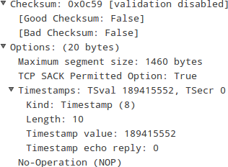

Fig. 14: TSecr value = 0

b.Go to the SYN-ACK packet in the TCP flow. The “timestamps” field should be similar to the below figure (Figure. 15). What is the value of TSecr?

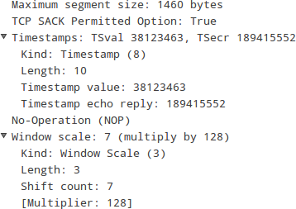

Fig. 15: TSecr value for SYN-ACK

The round trip time is calculated based on the receipt of SYN-ACK packet from the server. When the client receives the ACK packet, it subtracts the received TSecr from the current clock (OS Clock) to obtain the round trip clock difference.

Now, RTT = Round Trip Clock Difference * Clock Period

1. Flow Control
   1. In your Client-Server pcap, can you identify TCP out-of-order packets and TCP Dup ACKs?

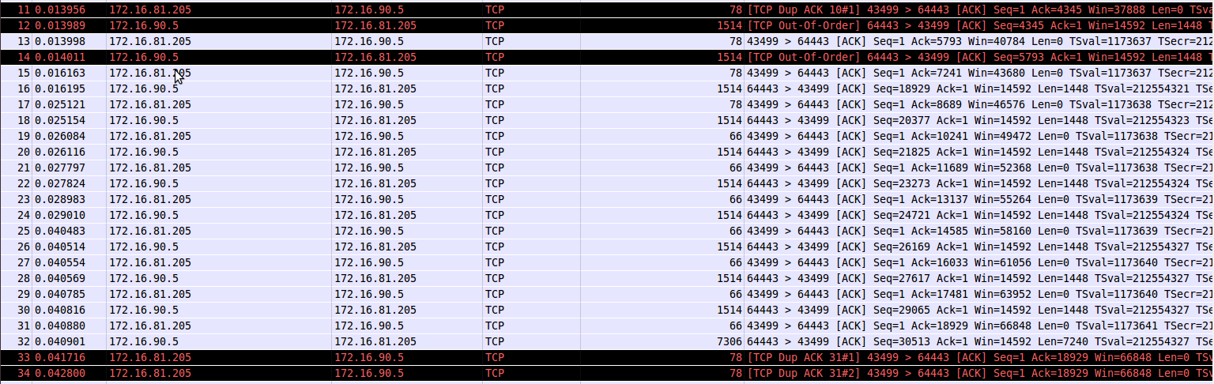

Fig. 16: TCP DUP ACKs and TCP out of order packets

b. Window Size scaling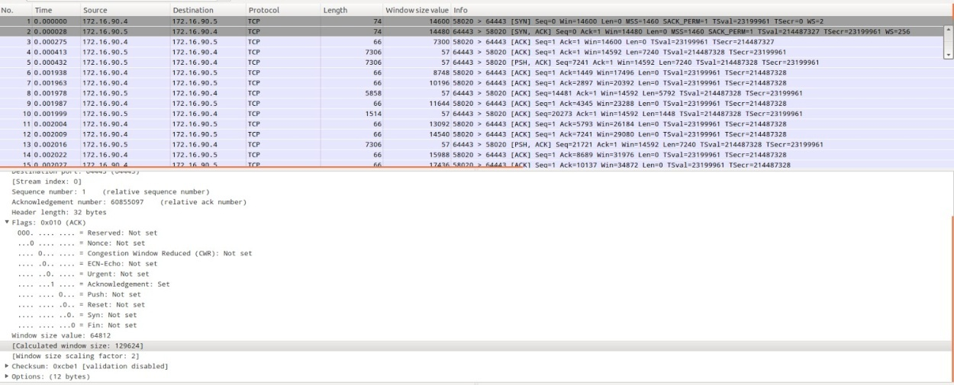

Fig. 17: Scaling window sizes

# References

* Unix Manual: <http://man7.org/linux/man-pages/man2/socket.2.html>
* Wireshark User’s Guide: [www.wireshark.org/docs/wsug_html_chunked/](http://www.wireshark.org/docs/wsug_html_chunked/)
* Wireshark Wiki Help: [wiki.wireshark.org/](http://wiki.wireshark.org/)

Experiment-8

# Aim: To learn Transmission Control Protocol (TCP) Flow Control, Error Control, and Congestion Control.

**TCP Flow Control:**

Automatic Repeat reQuest (ARQ), also known as Automatic Repeat Query, is an error-control method for data transmission that uses acknowledgements (messages sent by the receiver indicating that it has correctly received a data frame or packet) and timeouts (specified periods of time allowed to elapse before an acknowledgment is to be received) to achieve reliable data transmission over an unreliable service. If the sender does not receive an acknowledgment before the timeout, it usually re-transmits the frame/packet until the sender receives an acknowledgment or exceeds a predefined number of re-transmissions.

Selective Repeat is part of the automatic repeat-request (ARQ). With selective repeat, the sender sends a number of frames specified by a window size even without the need to wait for individual ACK from the receiver as in Go-back N ARQ. However, the receiver sends ACK for each frame individually, which is not like cumulative ACK as used with go-back-n. The receiver accepts out-of-order frames and buffers them. The sender individually retransmits frames that have timed out.

Tools used: Wireshark

# Experiment 1: Demonstration of TCP Flow Control techniques

1. Open capture.pcap file in Wireshark.
2. Each and every ACK packet should have ACK flag bit set. Check if it is true for all the ACK packets.
3. A SACK reports a block of bytes that is out of order. Find a couple of packets with SACK option set? Write down the sequence number of the packets carrying SACK options?
4. Identifying zero window size packets (figure above)

Go to Analyze->Expert Info composite. Under Warnings tab you should be able to see packet numbers which had zero Window.

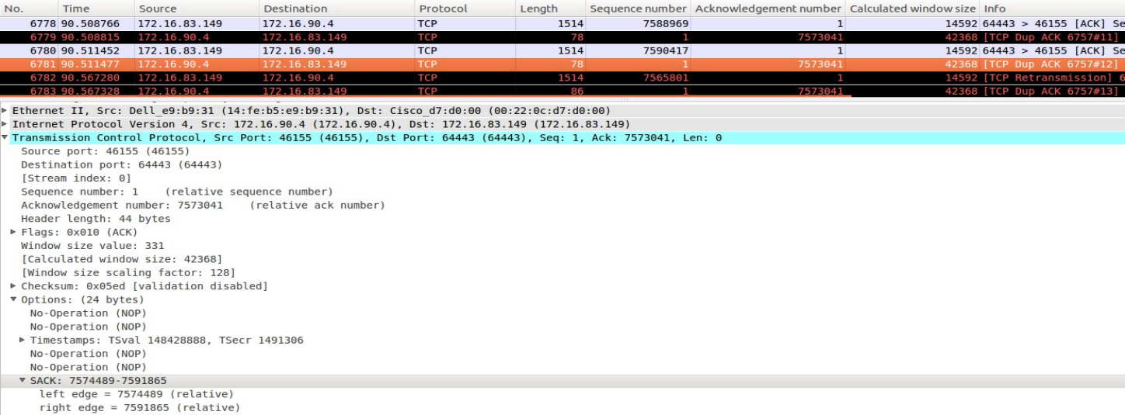

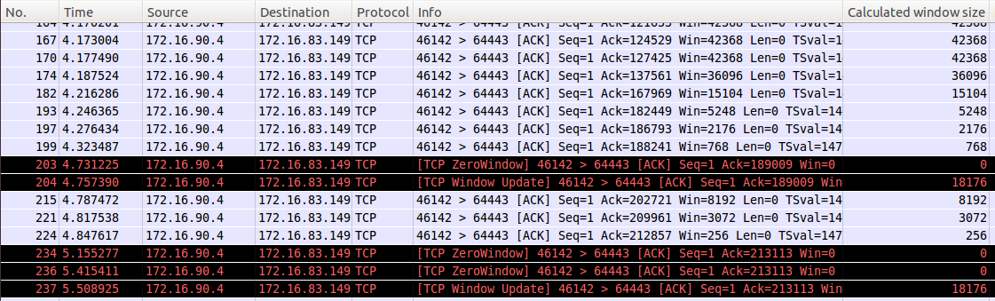

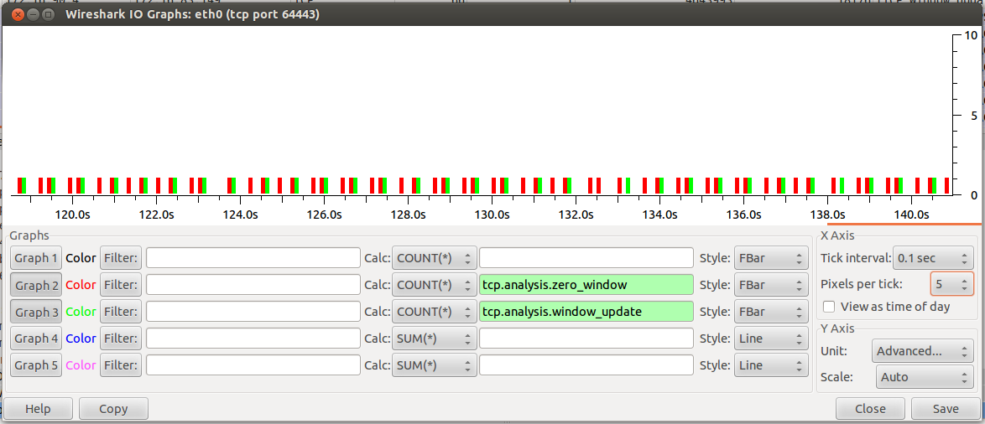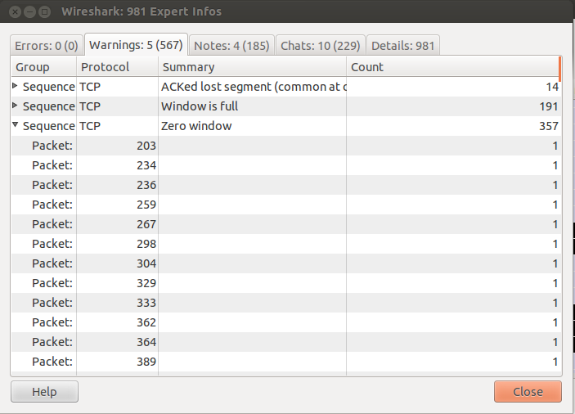

To identify zero window and window updates graphically:

Go to Statistics → IO graphs. For X axis, choose the Tick interval as 0.1 second and Pixels per tick as 5. For Y axis, choose Unit as Advanced. Plot graphs for tcp.analysis.zero_window and tcp.analysis.window_update as shown above. To generate the graph(s), click on the 'Graph *x*' (x=1,2,...) button at the left.

Similarly, you can generate a graph to observe TCP full window with zero window and window update.

Modify arguments as shown below:

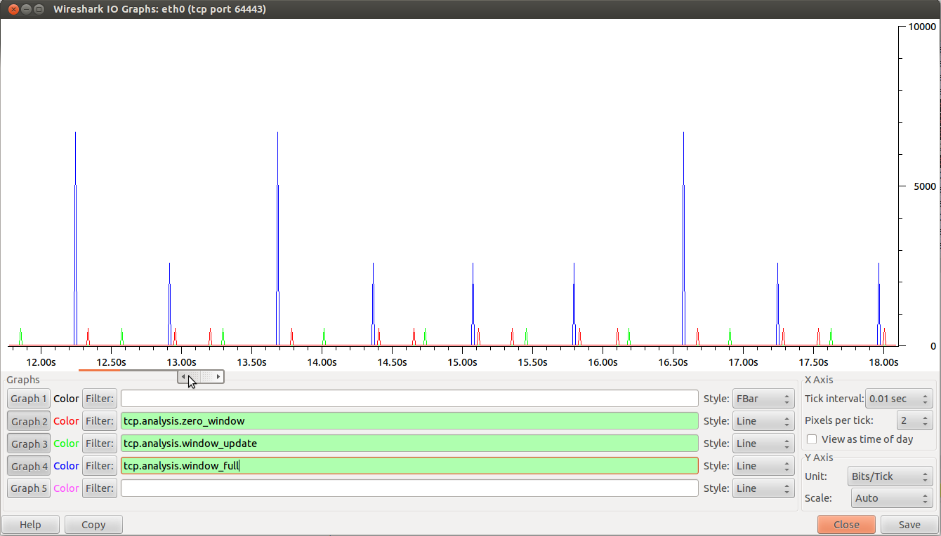

1. Response time IO Graphs (Inter-arrival time)

To observe time delay between packets, go to Statistics → IO graphs. For Y axis, choose the Unit as Advanced. Generate graph for time delay between packets as shown below. Large spike in the graph indicates large delays in time.

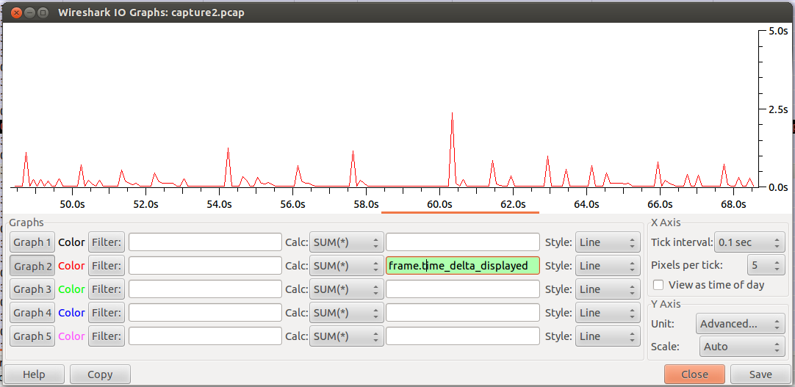

1. TCP Stream Graphs
   1. 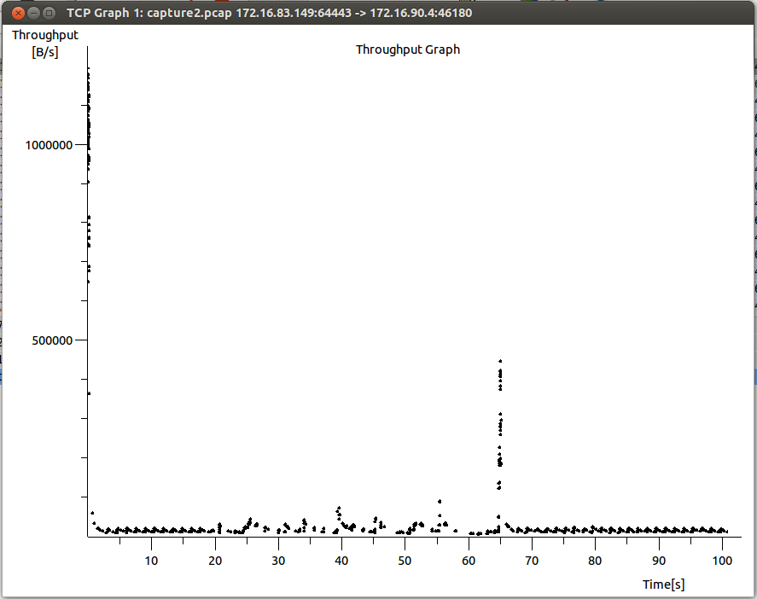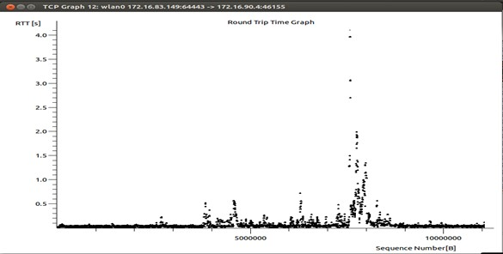Round Trip Time Graph

Filter packets going from Server → Client:

Go to Statistics → TCP stream graphs →Round Trip Time graph

In the graph shown below, you can see a spike occurring for RTT. The explanation for this behavior is that the graph was obtained for a capture done with the Server on a laptop with a wi-fi connection. The Server was deliberately moved away from the wi-fi access point in a zone of weak network strength, which led to increased RTT values of the packets.

* 1. Throughput Graph

Filter packets going from Server-> Client:

Go to Statistics-> TCP stream graphs->Throughput graph

* 1. Window Scaling Graph

Filter packets going from Client->Server:

Go to Statistics-> TCP stream graphs->Window Scaling Graph

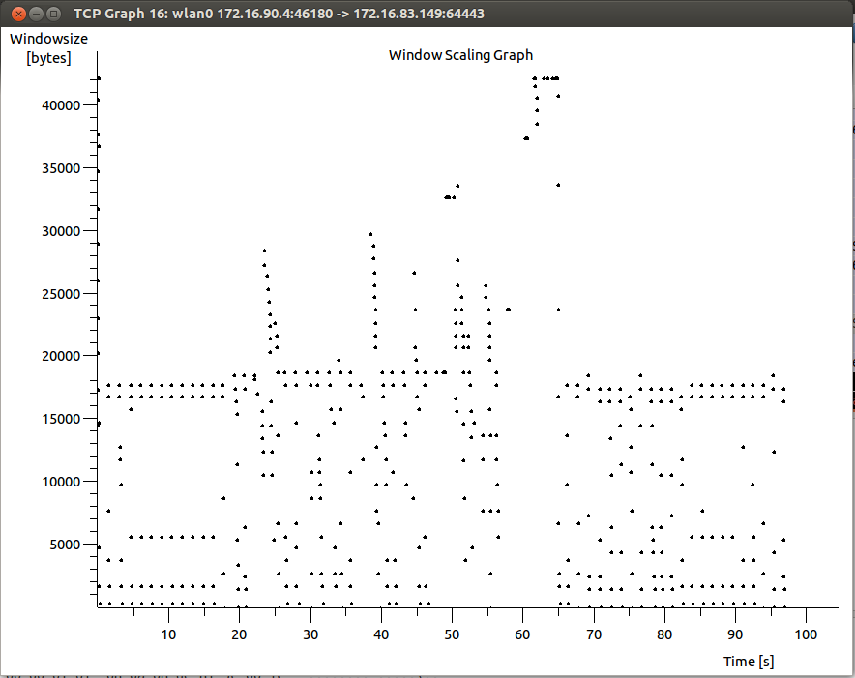

For better observations, you may zoom in the graph (Click the middle button on your mouse at the area which you want to zoom)

Window scale factors can be observed in the SYN packets sent from each side at the beginning of the TCP flow.

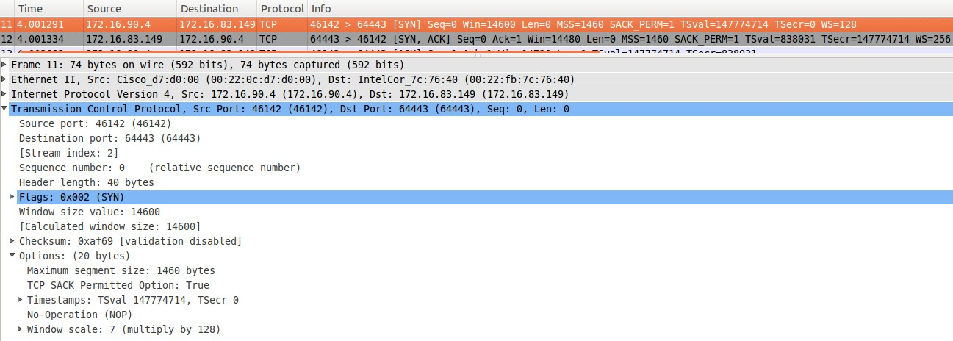

# TCP Error Control:

There are six important rules that define the generation of an acknowledgement. The rules are given below.

Tool used: Wireshark

**Experiment 2: Observation of Error Control in TCP protocol**

* 1. Rule1: Normal TCP Operation
  2. When end A sends a data segment to end B, it must include (piggyback) an acknowledgement that gives the next sequence number it expects to receive. This rule decreases the number of segments needed and therefore reduces traffic.
  3. Can you see acknowledgement packets that are piggybacked?

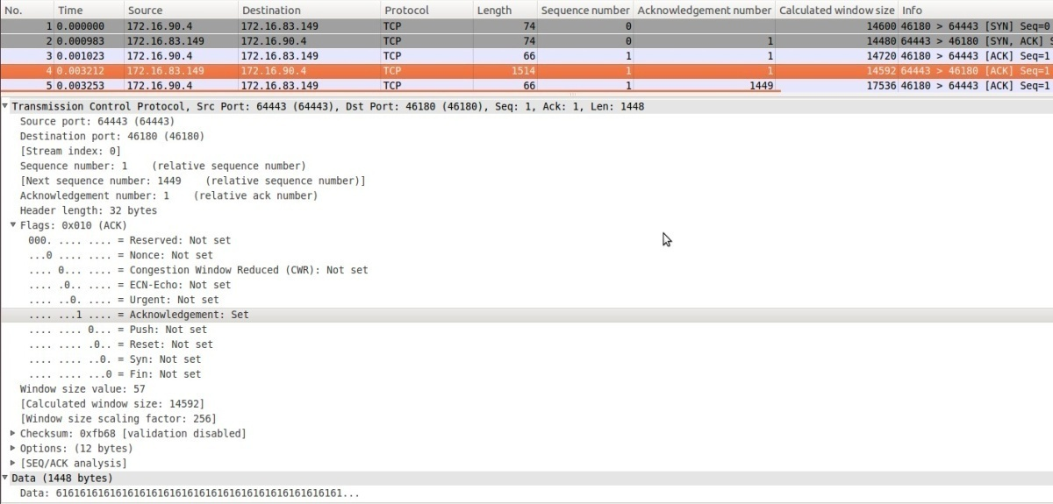

1. Rule2: Delayed ACK
   1. When the receiver has no data to send and it receives an in-order segment (with expected sequence number) and the previous segment has already been acknowledged, the receiver delays sending an ACK segment until another segment arrives or until a period of time (normally 500ms) has passed.
   2. We will observe this behavior along with rule 3.
2. Rule3: Preventing unnecessary retransmission of data segments.
   1. When a segment arrives with a sequence number that is expected by the receiver, and the previous in-order segment has not been acknowledged, the receiver immediately sends an ACK segment.
   2. Find the ACK packets in the pcap file which correspond to delayed ACK (rule 2) and rule 3. (See the two images below)

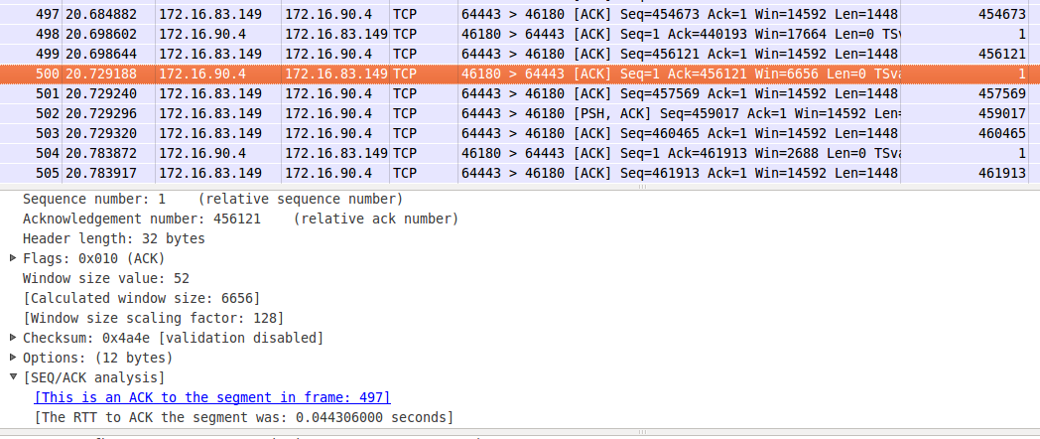

1. Rule4: Out-of-order sequence numbers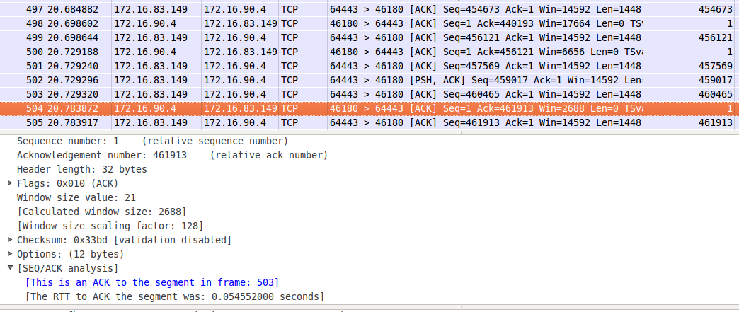
   1. When a segment arrives with an out-of-order sequence number that is higher than expected, the receiver immediately sends an ACK segment announcing the sequence number of the next expected segment.
   2. Find the out-of-order sequence numbered packets in the pcap file.

[7](http://wiki.wireshark.org/)

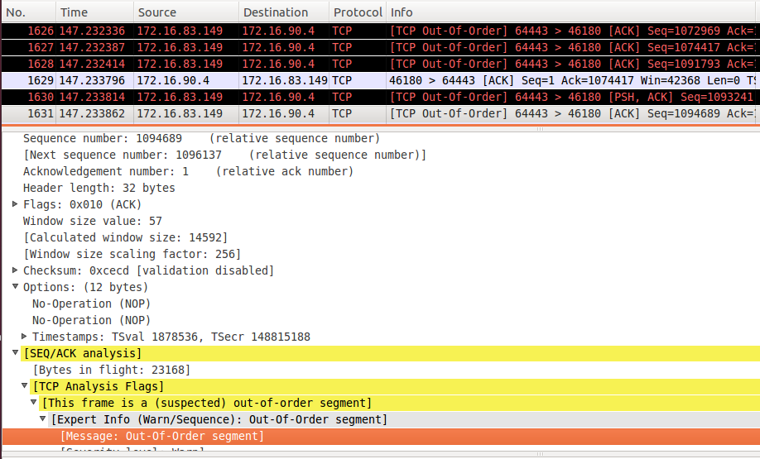

1. Rule5: Missing segments
   1. When a missing segment arrives, the receiver sends an ACK segment to announce the next sequence number expected. This informs the receiver that segments reported missing has been received.
   2. Find the transmission of missing segments in the pcap file (see the **last packet** in the figure below).
   3. Can you see their corresponding ACKs in the pcap file?

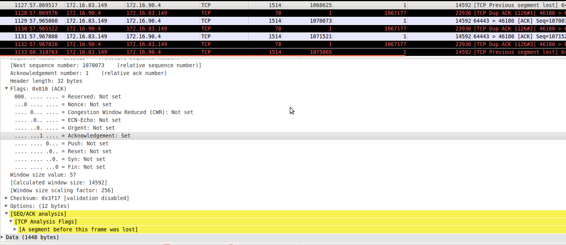

1. Rule6: Duplicated segments
   1. If a duplicate segment arrives, the receiver discards the segment, but immediately sends an acknowledgment indicating the next in-order segment expected.
   2. Find the transmission of duplicated segments in the pcap file.
   3. Do you see TCP Fast Retransmit happening after Dup ACKs?

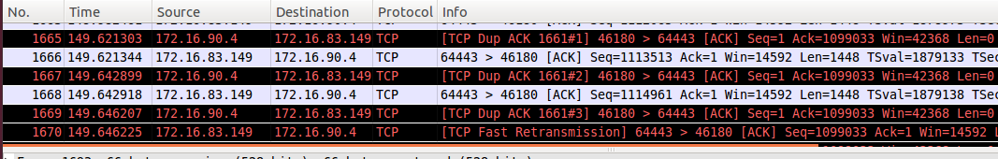

**TCP Congestion Control:**

Congestion can occur when data arrives from a fast network to a slower network. Congestion can also occur when multiple input streams arrive at a router whose output capacity is less than the sum of the inputs. TCP is mainly used to avoid congestion in the network. To avoid the congestion, some of the packets are dropped in the network. This may lead to retransmission of data packets.

Tool used: wireshark, tracepath

**Experiment 3: Demonstration of Congestion Control Techniques in TCP protocol**

1. Congestion control

In our Client-Server module, congestion can be observed at the Server when multiple clients try to connect to it one after another. The figure below explains the fair share behavior of TCP. You can make these observations yourself by running a concurrent server and connecting multiple clients to it (with some small time difference- say a few seconds).

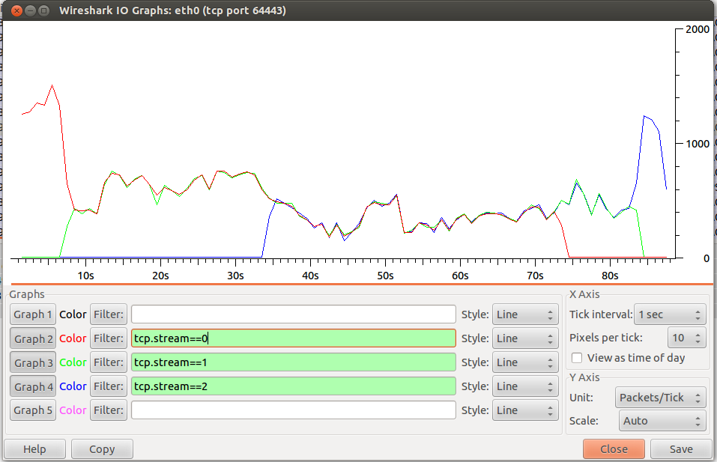

1. Find Path MTU using Tracepath tool

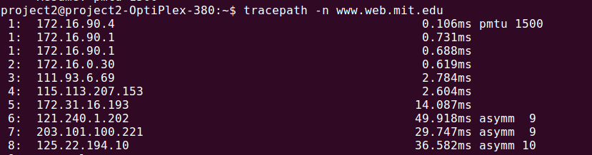

**User-Datagram Protocol (UDP):**

User-Datagram Protocol is a transport layer protocol used by many internet applications. In UDP, there is no handshaking between sending and receiving entities. For this reason, UDP is said to be connectionless.

Checksum is the 16-bit one's complement of the one's complement sum of a pseudo header of information from the IP header, the UDP header, and the data, padded with zero octets at the end (if necessary) to make a multiple of two octets. In other words, all 16-bit words are summed using one's complement arithmetic. The sum is then one's complemented to yield the value of the UDP checksum field.

If the checksum calculation results in the value zero (all 16 bits 0) it should be sent as the one's complement (all 1s).

Tool used: Wireshark

**Experiment 4: Observation of UDP Header fields**

1. Close all the browsers.
2. Run Wireshark in non-promiscuous mode with root privileges.
3. Download “udp_client.c” and “udp_server.c” from the CMS Website
4. Compile server first (as shown below).

gcc -o udp_server udp_server.c

1. Similarly, compile the client using the following command. gcc -o udp_client udp_client.c
2. Run the server using the below command.

./udp_server

1. The server will start, waiting for a client to connect. On a separate terminal window, run the client using

./udp_client 127.0.0.1

1. Payload size calculation
   1. Observe any UDP packet. The total length of UDP is given by the length of the header fields (8 bytes) plus the length of the data (1 bytes in this case).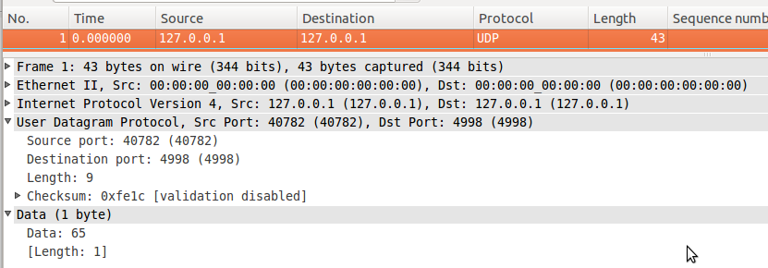

Answer the following questions based on your understanding of the above experiment.

1. What is the source port number?
2. What is the destination port number?
3. What is the total length of the user datagram?
4. What is the length of the data?

**References**

* Wireshark User’s Guide: [www.wireshark.org/docs/wsug_html_chunked/](http://www.wireshark.org/docs/wsug_html_chunked/)

# Experiment-9

# Aim: To give an Introduction to Wireshark &tcpdump, and observation of packets in a LAN network.

**Packet Sniffer:**

The basic tool for observing the messages exchanged between executing protocol entities is called a packet sniffer. As the name suggests, a packet sniffer captures (“sniffs”) messages being sent/received from/by your computer; it will also typically store and/or display the contents of the various protocol fields in these captured messages. A packet sniffer itself is passive. It observes messages being sent and received by applications and protocols running on your computer, but never sends packets itself. Similarly, received packets are never explicitly addressed to the packet sniffer. Instead, a packet sniffer receives a copy of packets that are sent/received from/by application and protocols executing on your machine.

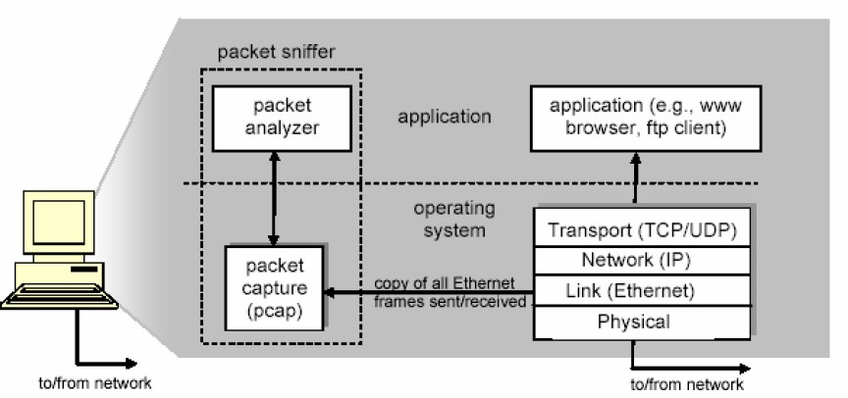

Figure1: Packet Sniffer Internal Structure

We will be using the Wireshark packet sniffer [<http://www.wireshark.org/>] for these labs, allowing us to display the contents of messages being sent/received from/by protocols at different levels of the protocol stack. (Technically speaking, Wireshark is a packet analyzer that uses a packet capture library in your computer). Wireshark is a free network protocol analyzer that runs on Windows, Linux/Unix, and Mac computers. It’s an ideal packet analyzer for our labs–it is stable, has a large user base and well-documented support includes a user guide. ([www.wireshark.org/docs/wsug_html_chunked/),](http://www.wireshark.org/docs/wsug_html_chunked/))manpages([www.wireshark.org/docs/man-pages/),](http://www.wireshark.org/docs/man-pages/))anda detailed FAQ ([www.wireshark.org/faq.html),](http://www.wireshark.org/faq.html)) rich functionality that includes the capability to analyze hundreds of protocols, and a well-designed user interface. It operates in computers using Ethernet, Token-Ring, FDDI, seria l(PPPandSLIP), 802.11wireless LANs, and ATM connections (if the OS on which it's running allows Wireshark to do so).

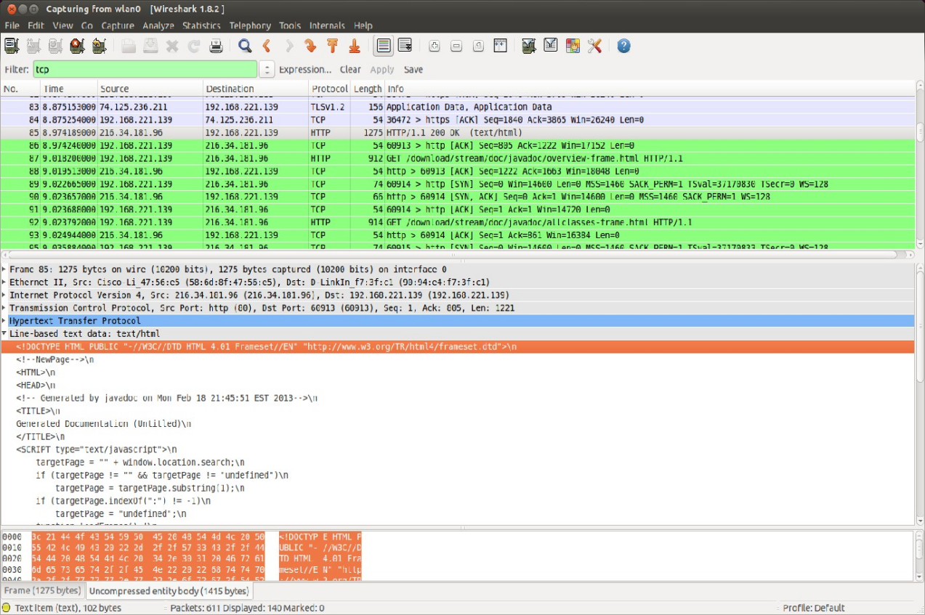

Figure2:Wireshark Snapshot Ubuntu

# Experiment1: Introduction to Wireshark

1. Install Wireshark using the following command. If already installed, then please go to step2.(One can also install from Ubuntu Software Center).

Sudo apt-get install wireshark

1. OneneedsadministratorprivilegestoworkwithWireshark.RunWiresharkwithsudo privileges (Type “sudo wireshark” in the Terminal).
2. Goto Capture->Optionsmenu.Check“eth0” interface and uncheck all other interfaces. Uncheck “Use promiscuous mode on all interfaces”.
3. Do packet capturing by clicking Capture->Start button. Now, the captured packets are shown in the center window. Stop capture (Capture->Stop button).
   * What is promiscuous mode of operation?
4. Filters–Therearedisplayfiltersandcapturefilters.Displayfilterscanbeusedonalready captured packets. Specify “tcp” in the display filter and press “Apply”.
   * What is the observation?
5. Capturefiltersisusedtofilteranynewincoming/outgoingpackets.Capturefilterscanbe specified in Capture->Options by typing in “Capture Filter” textbox.
6. Coloring rules–Depending on the protocol(IP,TCP,ARP,etc.)the color of the packet is different. These rules can be changed accordingly (View->Coloring Rules…).
7. Goto capture->interfaces. This will show all the interfaces available in the system.
   * How many interfaces does your system have?
   * Identify the IPaddress of “lo” interface.
8. Saving the output while capturing: After stopping the capture, do it from File->SaveAs.
   * Open try to open the pcap file in Wireshark.

# Experiment 2: Introduction to tcpdump

Tcpdump is a common packet analyzer that runs under the command line. It allows the user to intercept and display TCP/IP and other packets being transmitted or received over a network to which the computer is attached. Distributed under the BSD license, tcpdump is free software. Tcpdump works on most Unix-like operating systems: Linux, Solaris, BSD, OS X, HP-UX and AIX among others. In those systems, tcpdump uses the libpcap library to capture packets. The port of tcpdump for Windows is called WinDump; it uses WinPcap, the Windows port of libpcap.

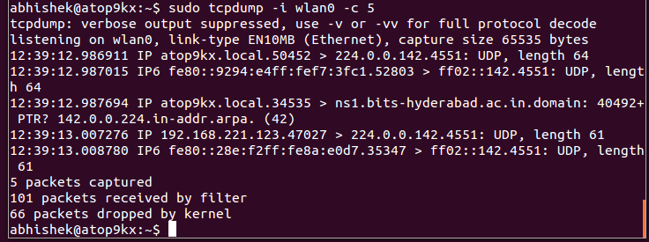

Figure3:tcpdump snapshot

If tcpdump is not already installed, run the below command to install it.

Sudo apt-get update

Sudo apt-get install tcpdump

1. Run tcpdump (with sudo privileges). Captured packets are displayed in each line (with minimal information).
2. Explore the various options in tcpdump
   * –i=>used to specify the interface to listen on(example:-ieth0)
   * –c => used to limit the total number of packets captured (example: -c 100 will capture100 packets and will stop)
   * –p=>run in non-promiscuous mode
   * –A=>displays the packets in ASCII format(-XXtodisplayinHEXformat)
   * –D=>lists only the interfaces
   * –w=>capture and write to a file(example:-wsample.pcap)
   * tcp=>capture only TCP packets
   * port<num>=>capture from a specific port no.
   * src<IP add#> => capture from specified source address. Try to differentiate sent and received packets.
   * dst<IP add#> => capture from specified destination address. Try to differentiate sent and received packets.

# Experiment3: Observation of packets in a LAN network

Figure4: A part of the BITS Hyderabad network

1. Close all browsers. Open a browser window and clear browser cache.
2. To view arp cache (On your Terminal: arp-a) (It displays MAC addresses, IP addresses, interface names). Depending on the subnet, the IP addresses of Cyberoam, default gateway, and DNS server will be shown.
3. Clear your system’s ARP cache(On your Terminal: ipneigh flushall)
4. Put the **eth0** interface down using **ifconfig down**(as explained in previous lab session)
5. Launch tcpdump along with ifconfig up(with **sudo** privileges).
   * sudo ifconfig eth0 up; sudo tcpdump -i eth0 c 1000 p w sample.pcap
   * Open a couple of websites in your browser(ex.google.com, yahoo.com)
   * Wait for tcpdump to stop.
6. Open sample.pcap file in Wireshark.
7. Observe on Wireshark how your system receives an IP address from the DHCP service. Identify the DHCP server’s IP address.
8. ObservetheARPpacketsbeingsent.IdentifytheIPandMACaddressofyourdefaultgateway.
9. Observe the DNS query being made to resolve the IP address of the website you visited. Identify the DNS server which responded to you.
10. By observing the packets in Wireshark, identify your own IP address and the IP address of the website you visited.
11. Explore Statistics->Endpoints to identify entities involved in capture.
    * Differentiate for the rnet, IP, TCP, UDP etc.,

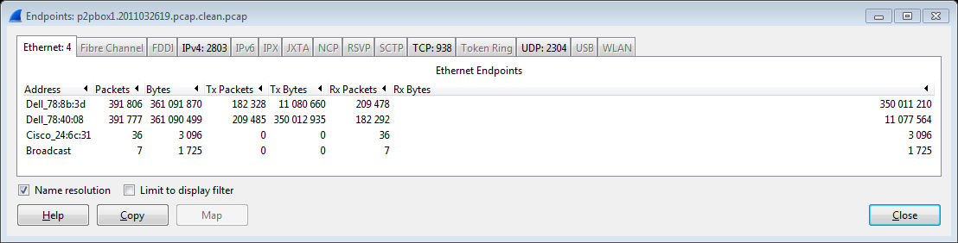

12.ExploreStatistics->Conversations to cover flows(pair of endpoints)

* + Observer different tabs(Ethernet, IP, TCP, UDP etc.).
  + Sort on different columns in TCP–e.g. Duration, Packets, Address A, RelStart etc.

You may also experiment with “FollowStream” button on the popup dialog which adds a Display filter

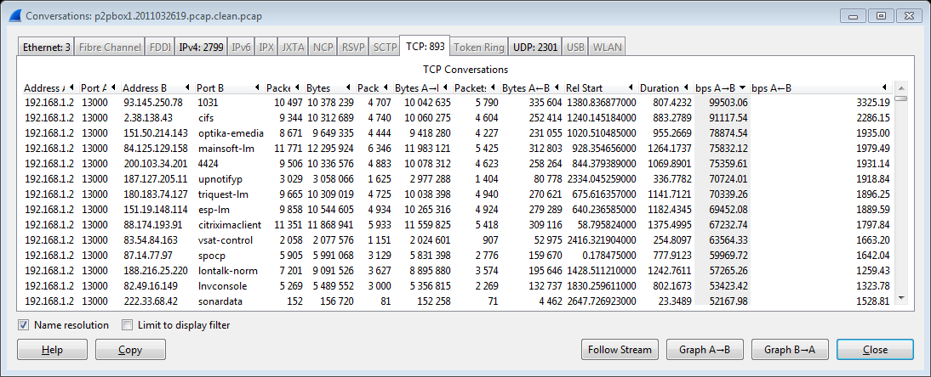

13.Explore Statistics->IOGraph for complete communication, and after filtering for TCP communication.

* + Compare two TCP flows–e.g.stream6 and 4 below.
  + Observe the time slider below the graph.

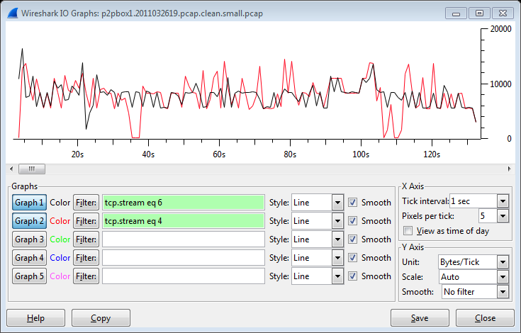

14.ExploreStatistics->FlowGraphtounderstandsequenceofeventsforthefilteredcapture.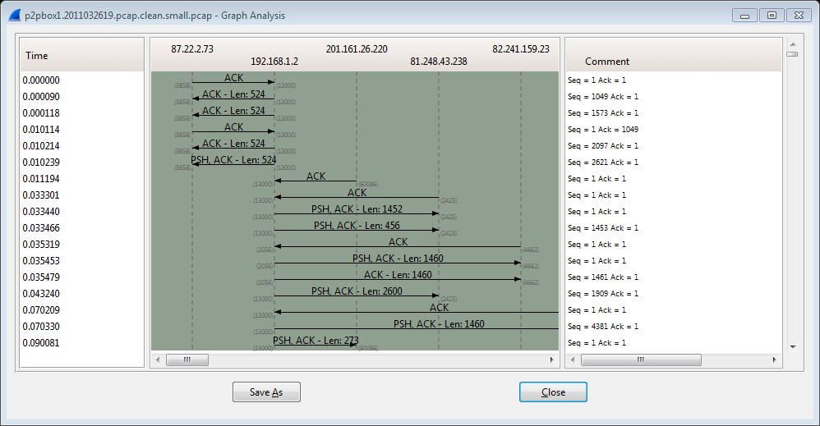

# References

* WiresharkUser’sGuide:[www.wireshark.org/docs/wsug_html_chunked/](http://www.google.com/url?q=http%3A%2F%2Fwww.wireshark.org%2Fdocs%2Fwsug_html_chunked%2F&sa=D&sntz=1&usg=AFQjCNHmIPDZSzqJwe2WL5HhiL7sT8Hw3A)
* WiresharkWikiHelp:[wiki.wireshark.org/](http://www.google.com/url?q=http%3A%2F%2Fwiki.wireshark.org%2F&sa=D&sntz=1&usg=AFQjCNEkoI9Ytw8QqucPhDtudEg1yDY3Ow)
* Tcpdumpdocumentation:[www.tcpdump.org/#documentation](http://www.tcpdump.org/#documentation)

**Experimet-10**

# Aim: To analyze HTTP packets using Wireshark tool, and understand the records returned by a DNS server.

**HTTP (Hypertext Transfer Protocol):**

The Hypertext Transfer Protocol (HTTP) is an application protocol for distributed, collaborative, hypermedia information systems. It is the foundation of data communication for the World Wide Web. Hypertext is structured text that uses logical links (hyperlinks) between nodes containing text. HTTP is the protocol to exchange or transfer hypertext.

HTTP functions as a request-response protocol in the client-server computing model. A web browser, for example, may be the client and an application running on a computer hosting a web site may be the server. The client submits an HTTP request message to the server. The server returns a response message to the client. The response contains completion status information about the request and may also contain requested content in its message body.

Tools used: Wireshark

# Experiment 1: Working of HTTP

1. Run Wireshark with sudo privileges. Start capturing in non-promiscuous mode.
2. Start up your web browser. Next, enter into your browser [http://timesofindia.indiatimes.com](http://timesofindia.indiatimes.com/).
3. Wait until the page is fully loaded. Now, stop the capture. Is your browser running HTTP version

1.0 or 1.1? What version of HTTP is the server running? (Refer Figure.1.)

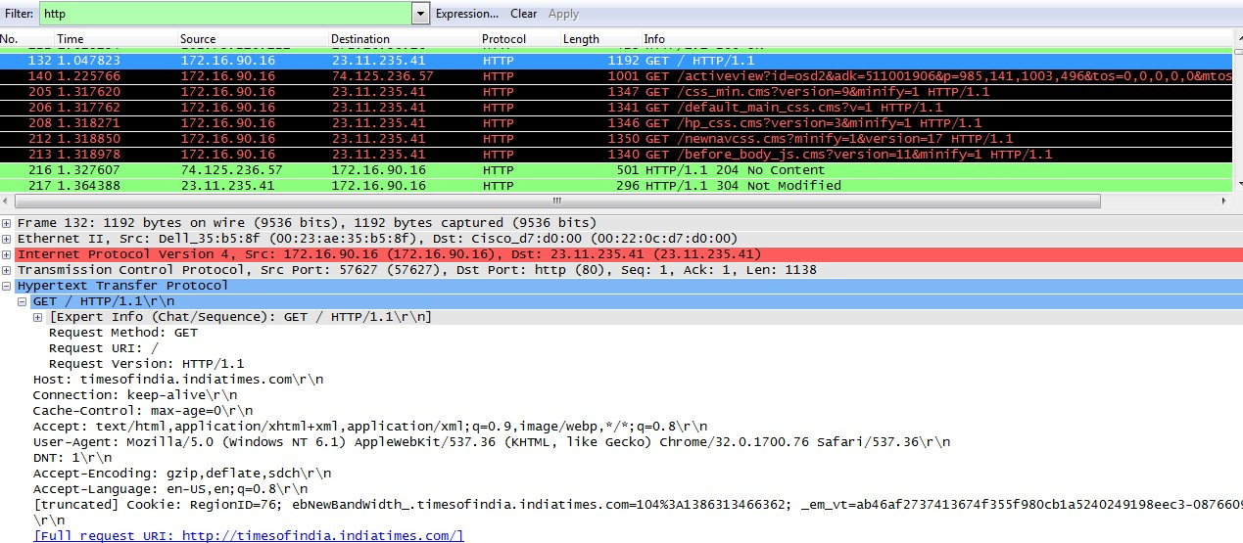

Figure.1. HTTP Request and Responses

1. Type “http” in the display-filter-specification window, so that only captured HTTP messages will be displayed later in the packet-listing window. A couple of the responses would have a response code of 304 (Not modified). What does the “Last-Modified” field imply? (Refer Figure.2.)

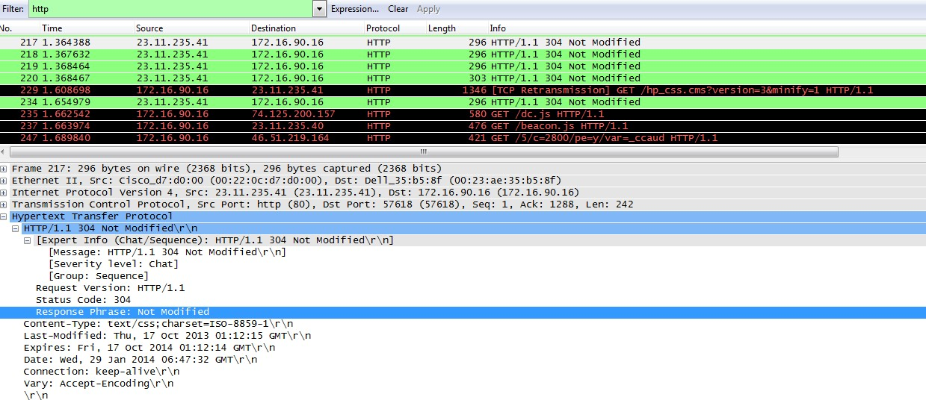

Figure.2. HTTP Not Modified page

1. Type “http.response.code==200” in the display-filter-specification window. Response code of 200 implies that HTTP request got processed successfully and HTTP response is sent to the browser window. You can explore different response codes like 304 (not modified), 404 (not found) etc. (Refer Figure.3.)

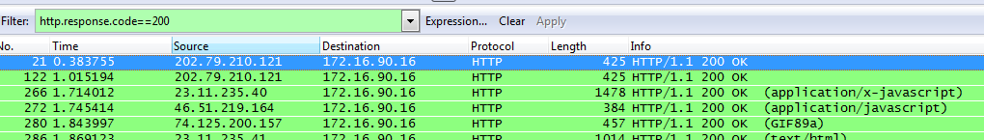

Figure.3. HTTP Response Code

1. Type “http.cookie” in the display-filter-specification window.

A cookie is a small piece of data sent from a website and stored in a user's web browser while the user is browsing that website. Every time the user loads the website, the browser sends the cookie back to the server to notify the website of the user's previous activity. (Refer Figure.4.)

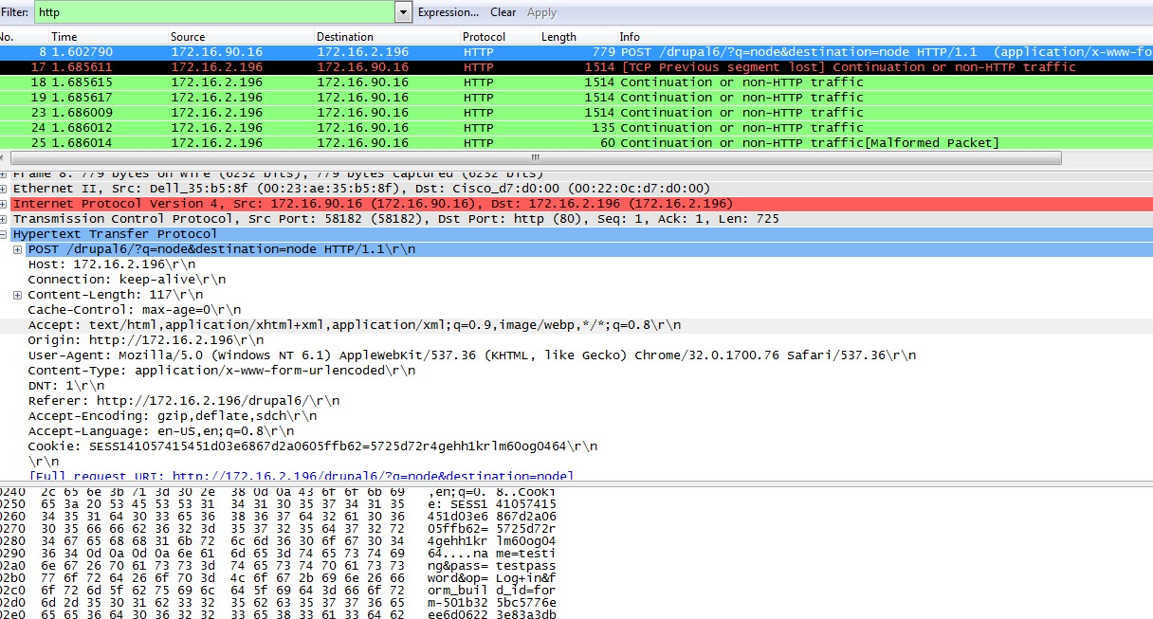

Figure.4. HTTP Cookie

1. Persistent v/s Non-Persistent HTTP connections. Do you see Connection: keep-alive set in your packet captures?
2. HTTP proxy set-up (Work in a team of two. First member will install proxy server and other will connect from a client)
   1. Install tinyproxy in Ubuntu (In the terminal: sudo apt-get install tinyproxy)
   2. Open tinyproxy.conf file using vi or gedit (In the terminal: sudo vi /etc/tinyproxy.conf)
   3. Uncomment the line “Allow 172.16.0.0/12” (Refer the figure below). By this, you are allowing anyone on 172.16.xx.yy to connect to your machine. Alternatively you may restrict access to one or few machines. To allow access to only your client, type the client machine’s IP address (add the following entry in the file: Allow <<IP of client>>) if you choose to do this, DO NOT uncomment the entry which was specified above.
   4. Save the file and exit.

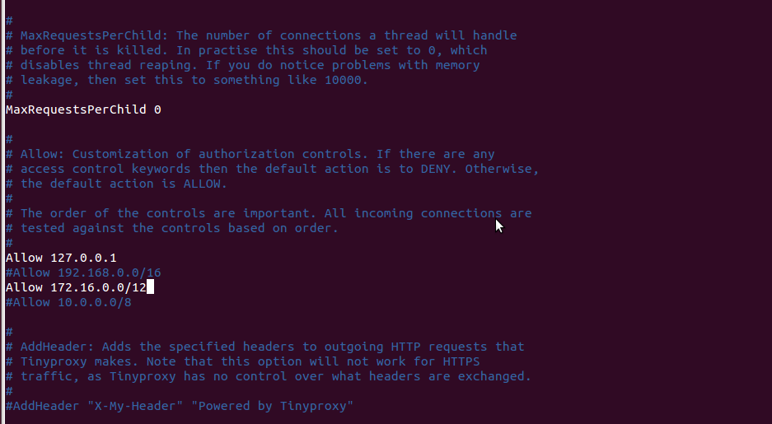

Figure.5. Tinyproxy configuration file

Now, restart Tinyproxy for the changes to take place. In the terminal: sudo /etc/init.d/tinyproxy stop

sudo /etc/init.d/tinyproxy start

Default port which is used by Tinyproxy is 8888.

Do the following on the other teammate’s PC (i.e., the client):

In Firefox, go to Edit → Preferences → Advanced tab →Network tab → Click on Settings

→Check ‘Manual proxy configurations’ →enter IP of proxy server and port (default port is 8888).

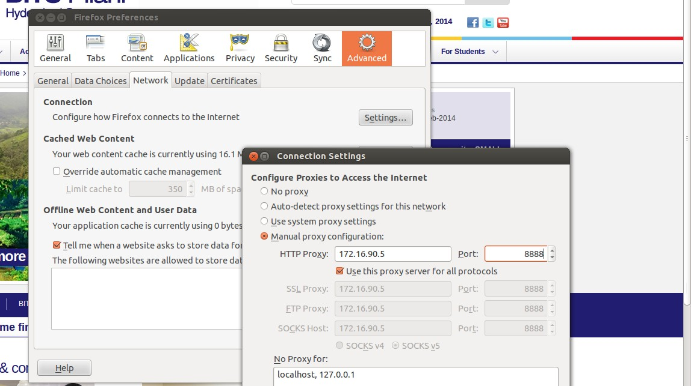

Figure.6. Firefox Settings

Now, on your client’s Firefox, connect to [www.google.com](http://www.google.com/), and capture packets on Wireshark (i) Firstly, when you are connected to the proxy, and (ii) Secondly, without being connected to the proxy. What differences do you observe?

When not connected to proxy, you can see the connection being made with [www.google.com](http://www.google.com/)

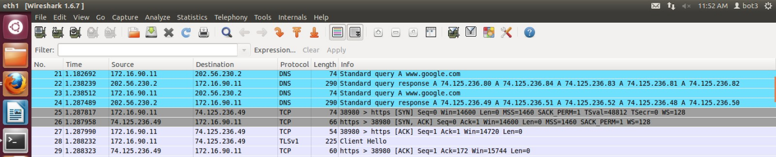

Figure.7. Response while not connected to proxy

1. When connected to the proxy, you can only see the proxy server!! (in this case, 172.26.90.4)

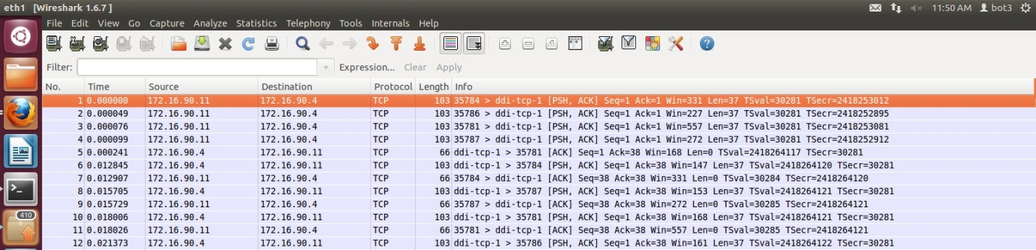

Figure.8. Response while connected to proxy

After you are done with your experiments, it is recommended to stop tinyproxy because if you're going to leave Tinyproxy running all the time, it will eventually eat all your memory and lock up your server.

sudo /etc/init.d/Tinyproxy stop

Before you leave, please remove tinyproxy from your machine so that the next lab’s students can have the opportunity to configure it themselves.

sudo apt-get remove tinyproxy

# DNS (Domain Name Server):

The Domain Name System (DNS) is a hierarchical naming system for computers participating in the Internet. It associates information with domain names assigned to each of the participants. Most importantly, it translates domain names meaningful to humans into the numerical (binary) identifiers associated with networking equipment for the purpose of locating and addressing these devices world- wide.

An often-used analogy to explain the Domain Name System is that it serves as the phone book for the Internet by translating human-friendly computer hostnames into IP addresses. For example, the domain name “[www.example.com](http://www.example.com/)” translates to the address 93.184.216.119 (IPv4).

# Experiment 2: Understanding the records returned by DNS website

1. Open “[network-tools.com/nslook/](http://network-tools.com/nslook/)” in a web browser. This website provides an online tool for DNS lookups.
2. Type “bits-pilani.ac.in” in the domain textbox (as shown in Figure. 9). Click “Go” button.

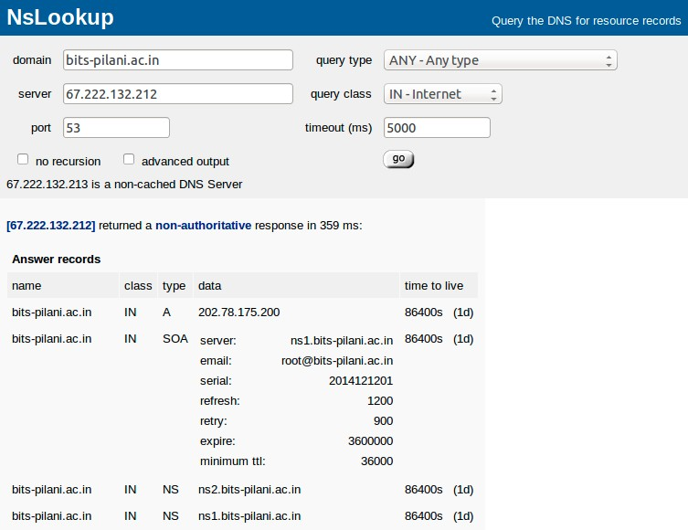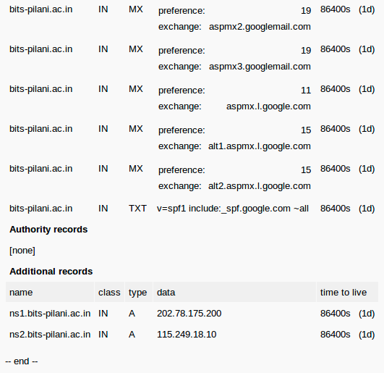

Figure.9. DNS Non-authoritative response

* + What is displayed in the Answer records?
  + What is the destination port number of the query message? What is the IP address to which the query message is sent?
  + How many additional records are found in the DNS response?
  + What are the IP addresses of BITS name servers?

1. Type “bits-pilani.ac.in” in the domain (as shown in Figure. 10). Change the server address to “202.78.175.200”. Click “Go” button.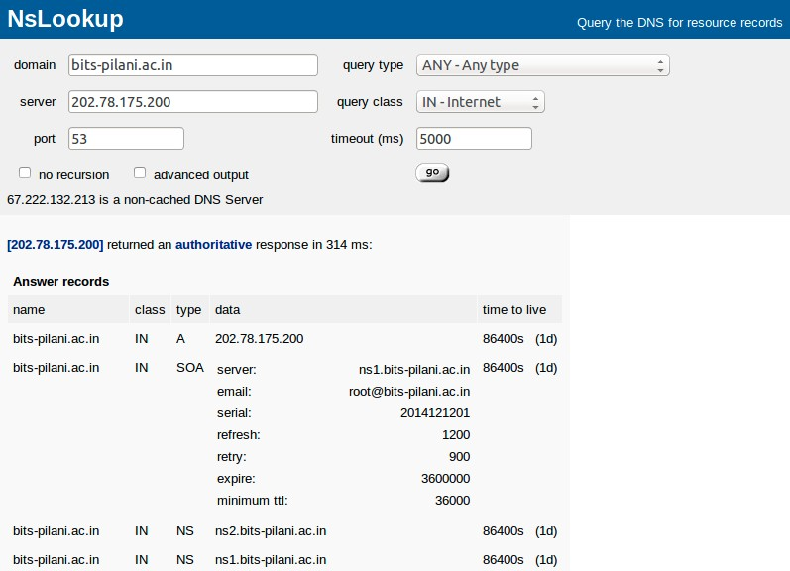

Figure.10. DNS Authoritative response

* + What is an authoritative response?

1. Type “root-servers.net” in the domain (as shown in Figure.11.). Click “Go” button.
   * What is displayed in Answer records?
   * What is the total number of root servers?
   * What is displayed in the Additional records?
   * What is the IPv4 and IPv6 address of a.root-servers.net?





Figure.11. DNS Root servers

**References**

➢ Wireshark HTTP: http://code.bretonstyle.net/?page_id=176

➢ Tinyproxy link1: http://www.justinmccandless.com/blog/Set+Up+Tinyproxy+in+Ubuntu

➢ Tinyproxy link2: http://www.gypthecat.com/tinyproxy-a-quick-and-easy-proxy-server-on-ubuntu

➢ Online DNS Lookup Tool: network-tools.com/nslook